 | Autumn 1 | Autumn 2 | Spring 1 |  | Spring 2 |  | Summer 1 |  | Summer 2
British Values | Fundamental British Values (Ongoing)  Democracy: making decisions together (PSED: BR, MS & SR) - Children to know their views count, value each other’s views and values and talk about their feelings. When appropriate demonstrate democracy in action, for example, children sharing views on what the theme of their role play area could be with a show of hands.  Rule of law: understanding rules matter (PSED: BR, MS & SR) - Children understand their own and others’ behaviour and its consequences, and learn to distinguish right from wrong. Rules and the codes of behaviour, for example, to agree the rules about tidying up and ensure that all children understand rules apply to everyone.Individual liberty: freedom for all (PSED: BR, MS & SR; UW: P, C & C) - Develop a positive sense of themselves, develop their self-knowledge, self-esteem and increase their confidence in their own abilities, for example talking about their experiences and learning. Explore the language of feelings and responsibility, reflect on their differences and understand we are free to have different opinions. (Link to Mindfulness)  Mutual respect and tolerance: treat others as you want to be treated (PSED: BR, MS & SR; UW: P, C & C) - Ethos of inclusivity and tolerance where views, faiths, cultures and races are valued and children are engaged with the wider community. Acquire a tolerance and appreciation of and respect for their own and other cultures; know about similarities and differences between themselves and others and among families, faiths, communities, cultures and traditions and share and discuss practices, celebrations and experiences. Importance of tolerant behaviours such as sharing and respecting other’s opinions, promote diverse attitudes and challenge stereotypes, for example, sharing stories that reflect and value the diversity of children’s experiences and providing resources and activities that challenge gender, cultural and racial stereotyping
British Values | Respects/ Diversity/ Rule of Law  Respect - We value respect by showing good behaviour and polite manners. Diversity - We value diversity by respecting everyone’s differences. School rules, Class rules, School Values, Behaviour in school and Positive play. | Mutual Respect Kindness and Diversity  Responsibility - We value our responsibility within our community.  Kindness - We value kindness as it helps to build friendships.  Fair play, Diwali, Remembrance Day, Christmas Story, Assemblies | Effort and Honesty  Effort - We value effort as it shows our determination to succeed.  Honesty - We value honesty by always telling the truth and taking responsibility for our actions.  Chinese New Year, Pancake day |  | Loyalty and Forgiveness  Loyalty - We value loyalty because it means we can trust and depend on each other.  Forgiveness - We value forgiveness as it shows strength of character. |  | Determination and Teamwork  Determination - We value determination so we can tackle difficulties in school and in life.  Team work - We value team work as together we learn. |  | Courage  Courage - We value courage as taking risks helps us to become confident people.  Moving to a new class – transition.
Theme | Marvellous Me!  Seasonal Changes in Autumn | Autumn Festivals  Seasonal Changes in Winter | Magical Tales &  Cold Places  Seasonal Changes in Winter |  | Under the Sea  Seasonal Changes in Spring |  | Growing  Seasonal Changes in Spring |  | The Wider World!  Seasonal Changes in Spring
Topic Overview | Settling into school and making friends  Learning daily routines  Learning how to be helpful, kind, thoughtful  Knowing that we are all unique and special  Simple mapping of our school and the village  Me and my Community – our family, our school community and local community  People Who Help Us  Seasonal changes in Autumn | Learning about celebrations during Winter and Autumn  Festivals from different cultures including Bonfire Night, Diwali,  Famous figures from the past – Guy Fawkes.  Remembrance Day, Hannukah and Christmas  Recognising changes in the seasons in Winter  Exploring animals who hibernate in Winter  Exploring darkness and light, including shadows – using torches | Considering new starts in the New Year  Developing a love of stories  Learning, retelling, dramatizing familiar traditional tales  Learning about characters, settings and narratives  Exploring places in the world which are cold – Polar Regions  Seasonal Changes in Winter Exploring ice |  | Pirates: Real pirates in history, following pirate maps to find treasure and real shipwrecks  Learning about animals that live in the sea  Learning about some seaside habitats and which animals live there.  Boats – floating and sinking and Archimedes Bath  Seasonal Changes in Spring  Easter – the story of Easter |  | Plant part names  What do plants need to grow  Growing beans, sunflower seeds and vegetables  How does our food grow?  Healthy Eating  Lifecycles – caterpillar to butterfly and frogspawn to tadpole to frog.  Minibeasts – where do they live, hunting for and naming some common minibeasts  Seasonal Changes in Spring  Art by famous artists Vincent Van Gogh and Claude Monet |  | Geographical features of Clitheroe  Sharing places around the world that we know from holidays and trips.  Contrasting countries around the world: Weather, cultures, food and animals around the world.  Animal habitats in contrasting areas.  Seasonal Changes in Summer  Common summer wild plant names
Trips and Visits | Walk and Talk  Post Office and Community Walk  People Who Help Us Visits (Police, Fire Service, Nurses, Vicar)  Church visit – Harvest Festival | Walk and Talk  Church visit – Christmas  Father Christmas | Walk and Talk |  | Walk and Talk  Church visit – Easter |  | Walk and Talk  Farm Visit |  | Walk and Talk  Blackpool Zoo Visit  Seaside
RE Theme and Story | EYFS 1: I Am Special – Clever Cub Explores God’s Creation  EYFS 2: Harvest – Clever Cub Gives Thanks | EYFS 3: Special People – Clever Cub Learns to Share  EYFS 4: Christmas – Clever Cub Welcomes Baby Jesus | EYFS 5: Stories Jesus Heard – Clever Cub Tells the Truth, Clever Cub Trusts God  EYFS 6: Stories Jesus Told – Clever Cub Learns about Love  EYFS 7: Easter – Clever Cub and the Easter Surprise |  |  |  | EYFS 11: Special Times |  | EYFS 10: Prayer – Clever Cub Sings to God
Other Cultural Themes | 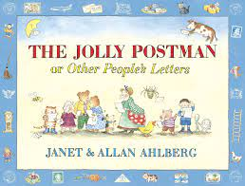  Harvest | Diwali  Birthdays and Christmas  Remembrance  Bonfire Night | Lunar New Year  Mother’s Day |  | Palm Sunday, Good Friday and Pancake Day/Shrove Tuesday  Easter Sunday  Ramadan  Eid Al-Fitr  Vaisakhi  Lent  Holi |  | Pentecost |  | Father’s Day  Eid Ul-Adha
Core and Supporting Texts  A bank of familiar texts/ traditional tales will be read daily to the children at story time. This will enable them to orally re-tell popular texts and stories independently. | The Colour Monster  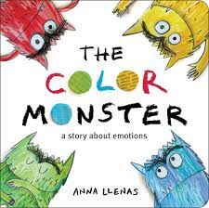  The Colour Monster Goes To School  Elmer  Superhero Dad  My Mum  Families, Families, Families  Martha Maps it Out  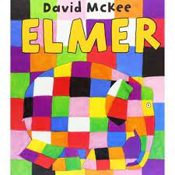  Topsy and Tim People Who Help Us stories  The Jolly Postman  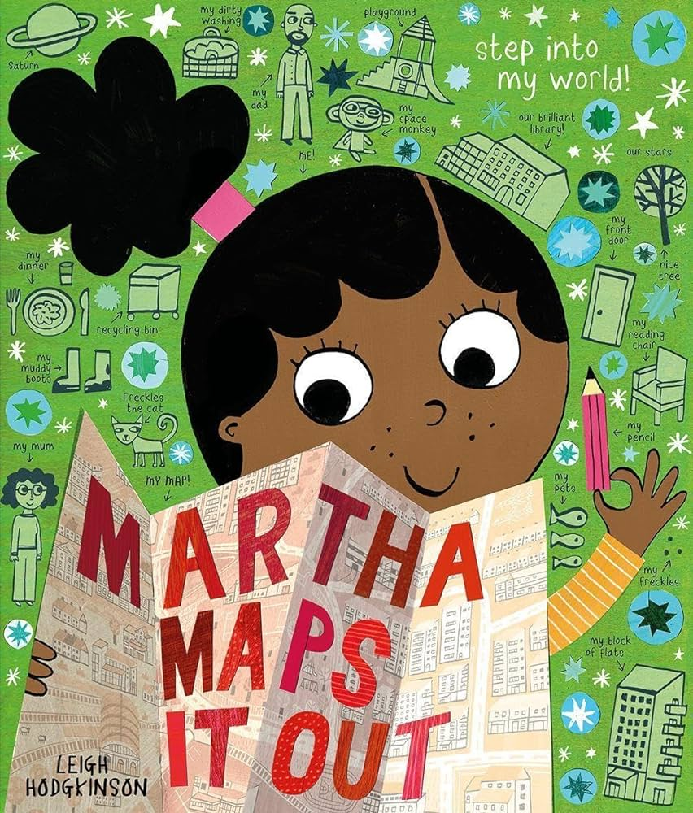  Leaf Man  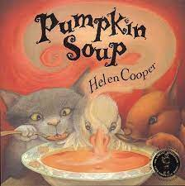  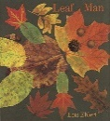  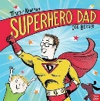  Pumpkin Soup | 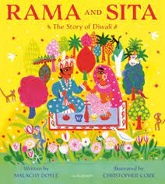  Rama and Sita  Jack Frost  The Snowman  The Nativity  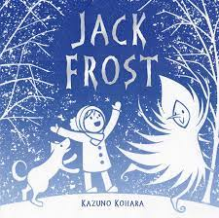  The Gingerbread Man  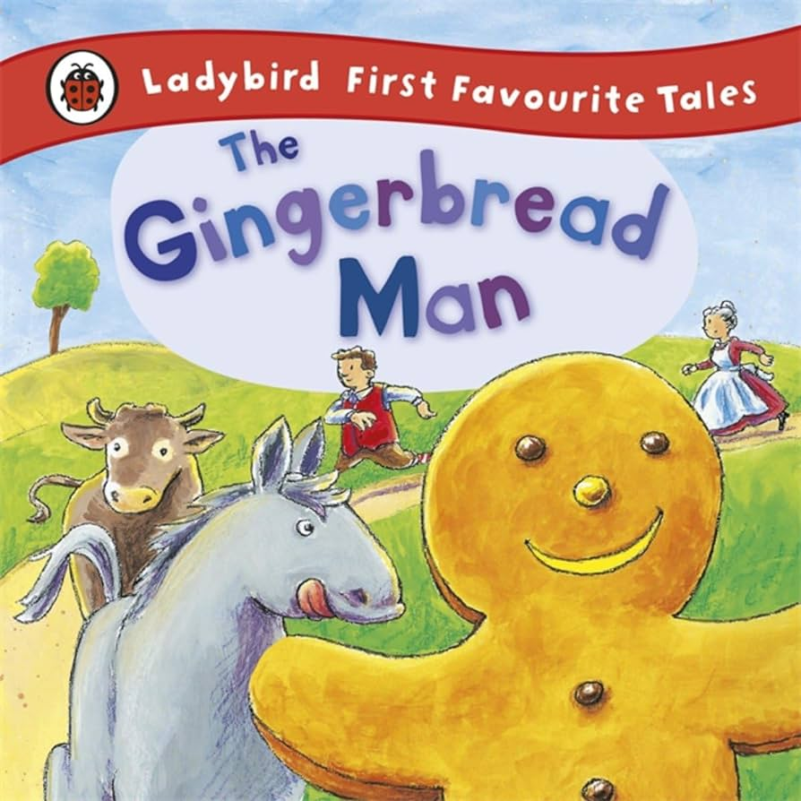  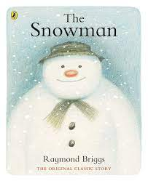  Winter Stories  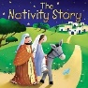 | 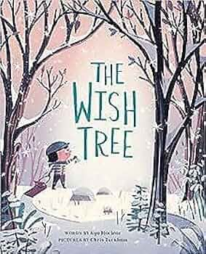  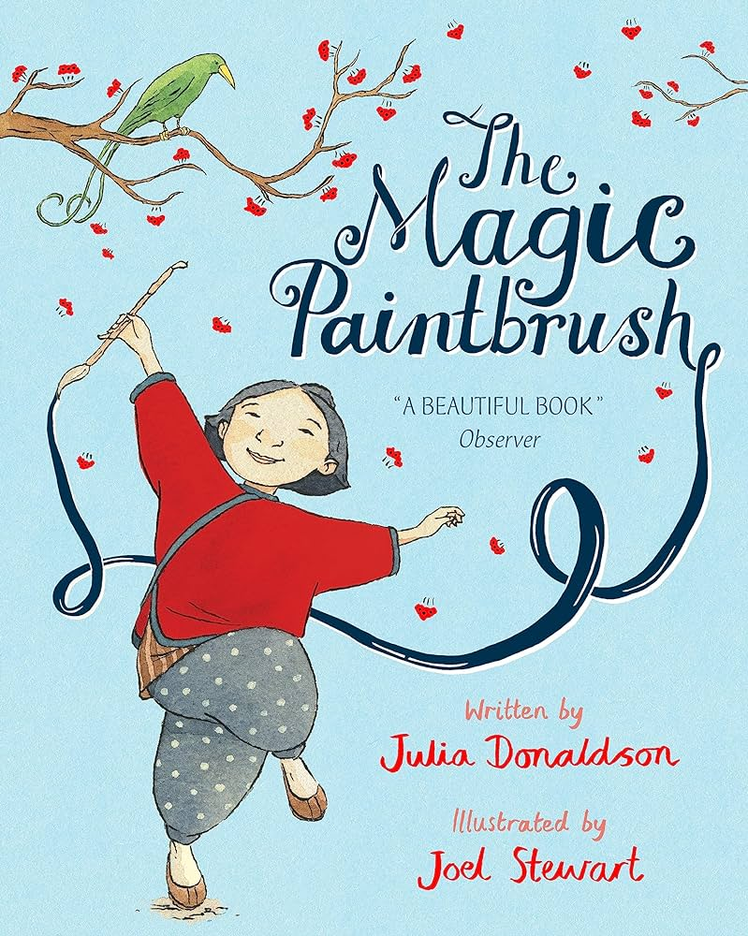  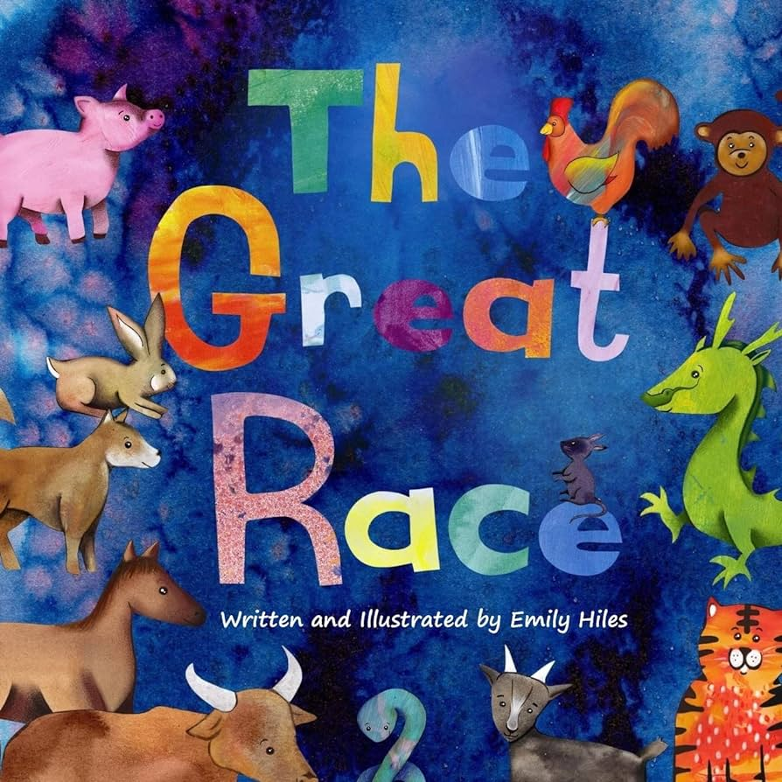  The Wish Tree  The Great Race  The Magic Paintbrush  Various Traditional Tales  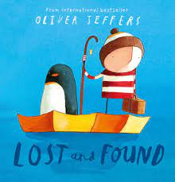  Lost and Found  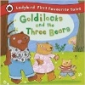  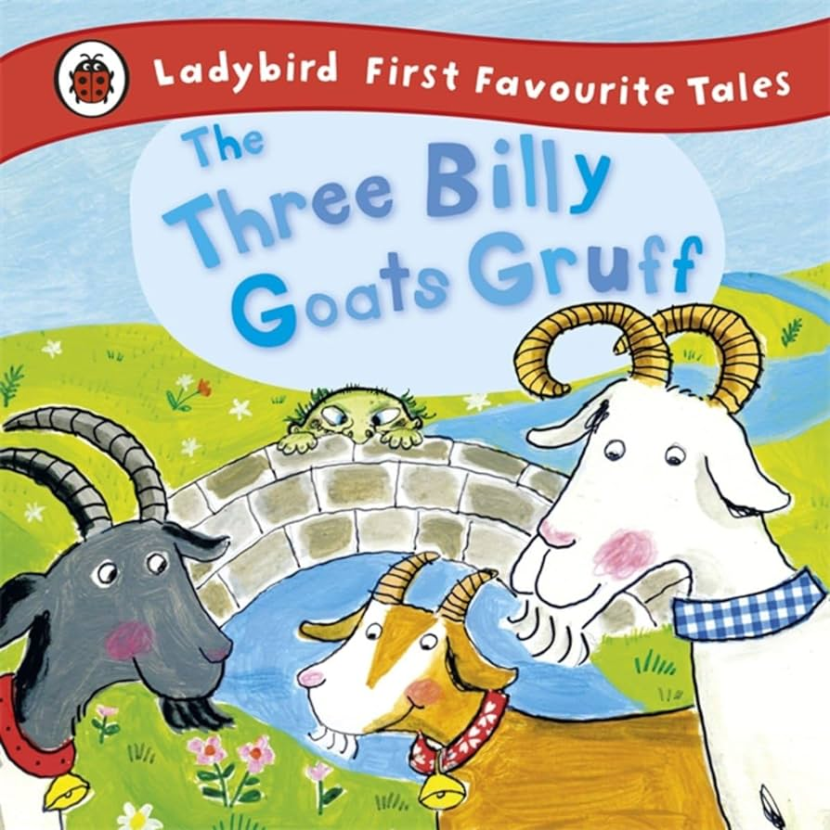  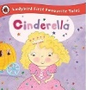 |  | 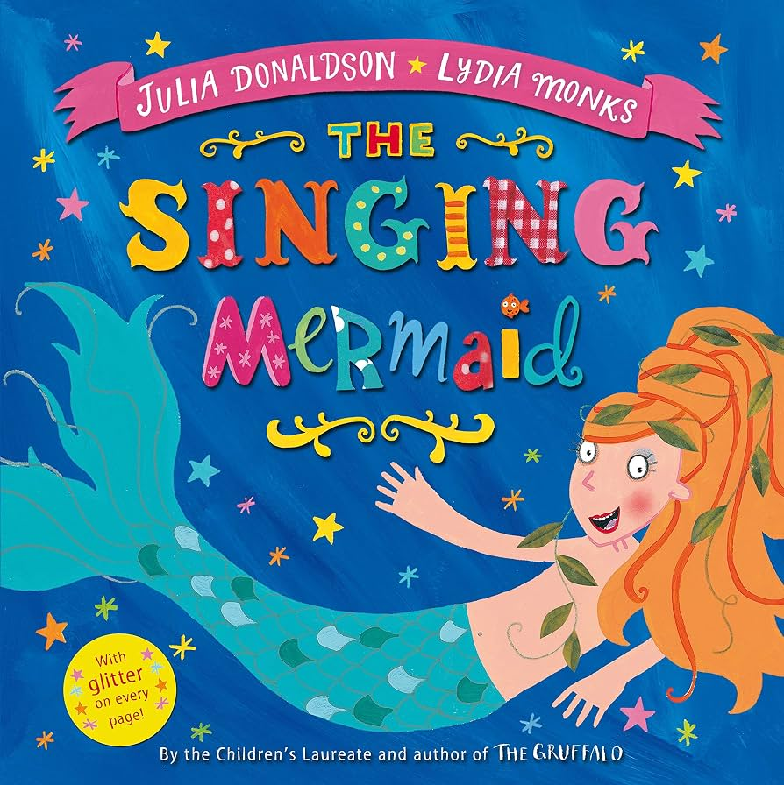  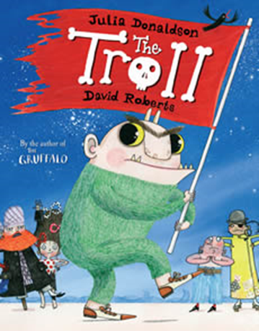  Goodbye Winter, Hello Spring  The Night Pirates  The Troll  Archimedes Bath  Tiddler  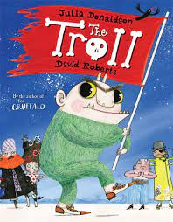  The Singing Mermaid  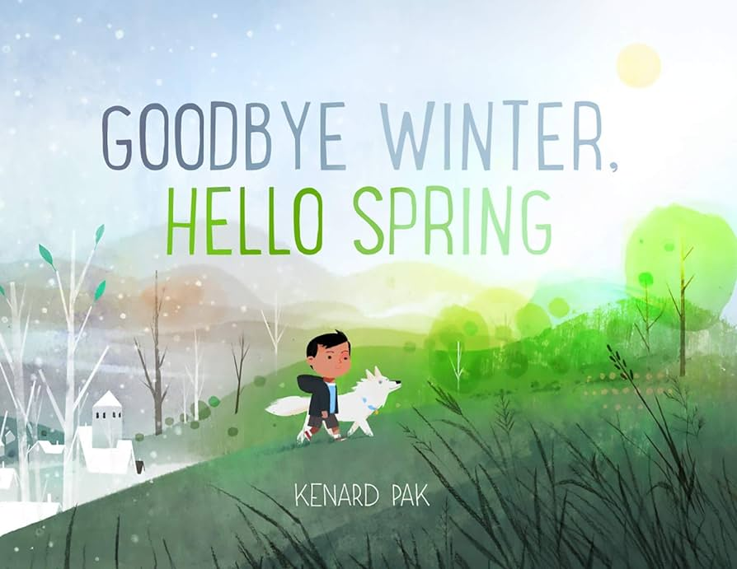  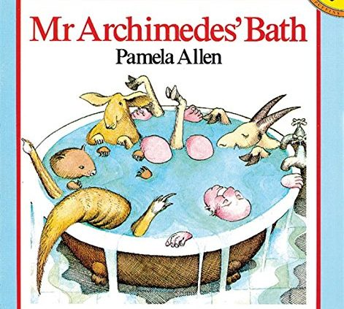  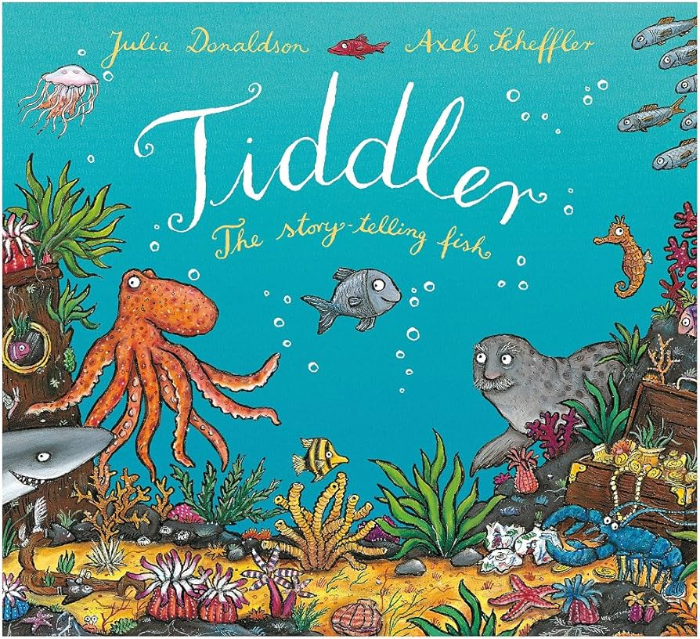  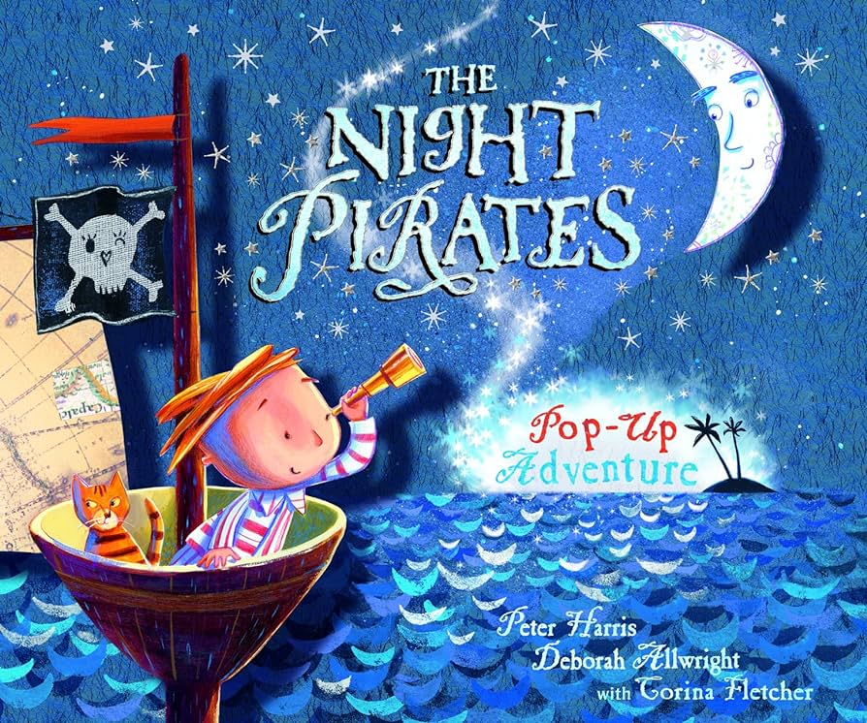  The Easter Story |  | 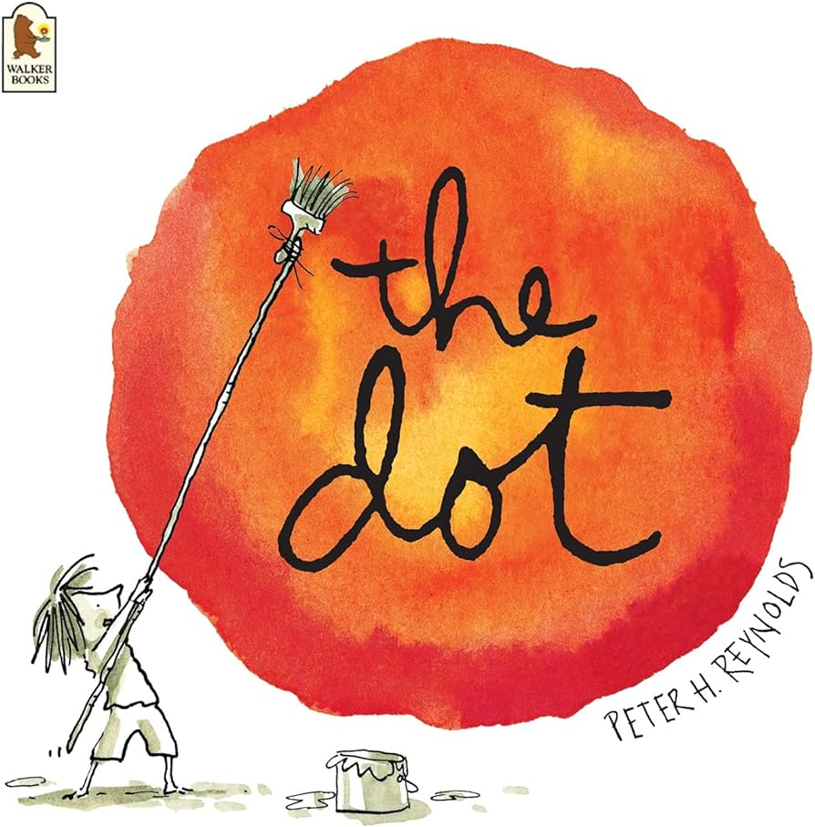  Jack and the Baked Beanstalk  Oliver’s Vegetable  Tadpole’s Promise  The Magical Garden of Claude Monet  Camille and the Sunflowers  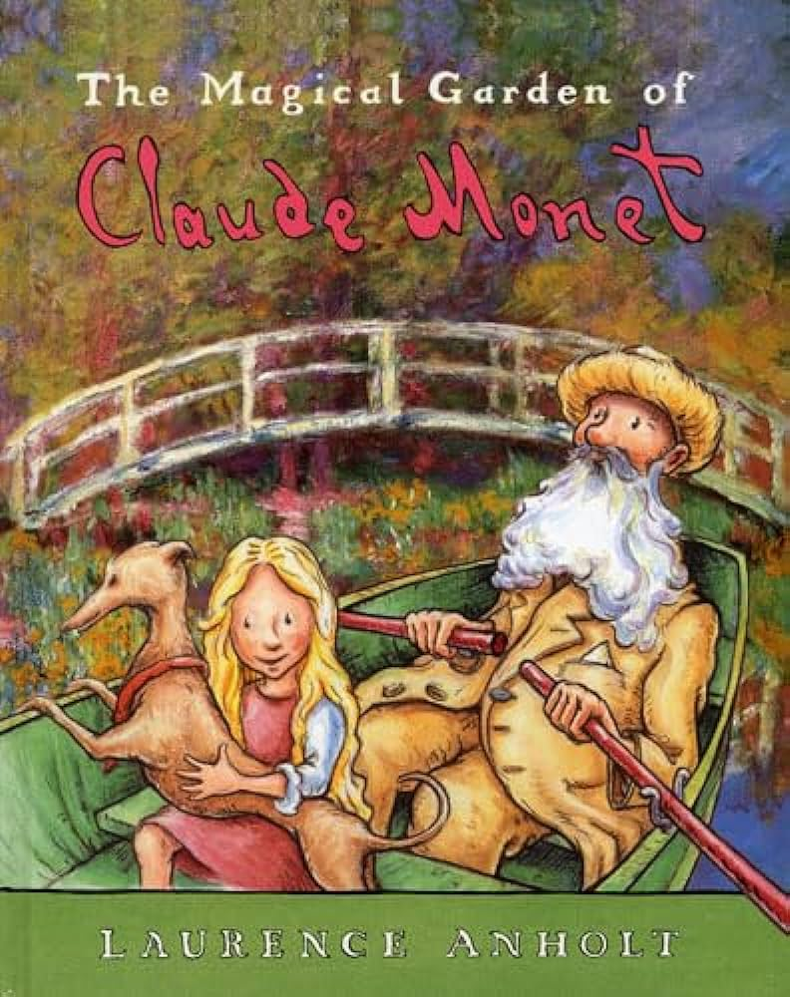  The Dot  From Caterpillar to Butterfly  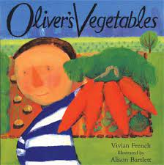  Mad About Minibeasts  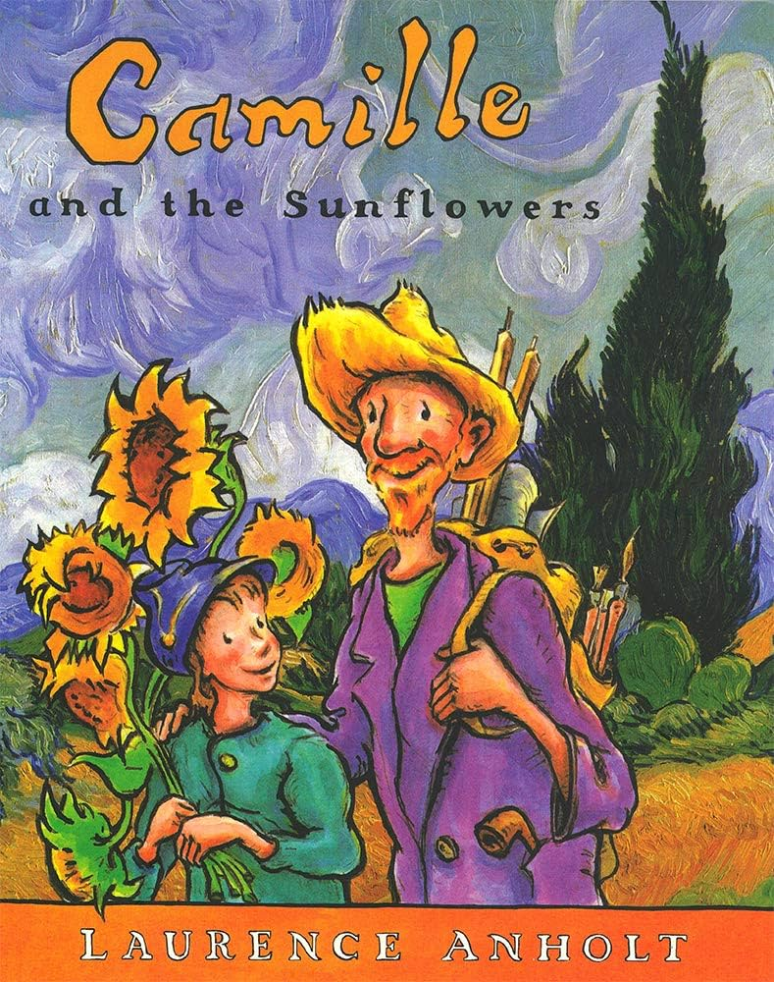  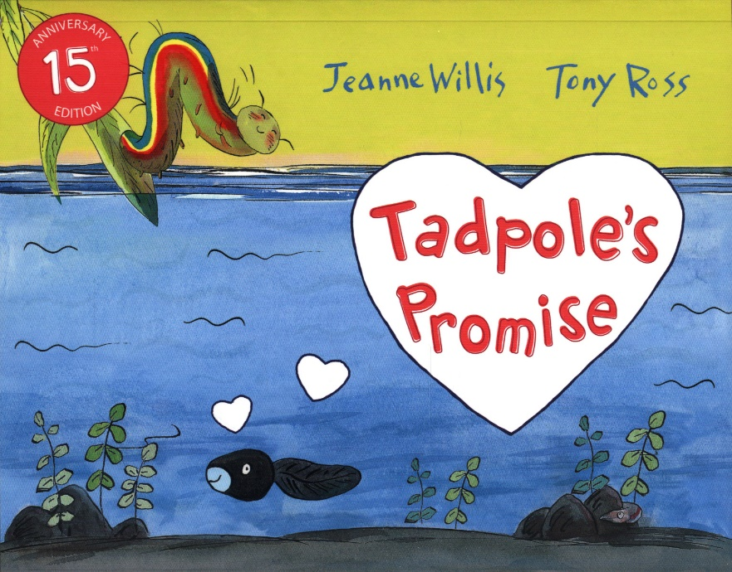  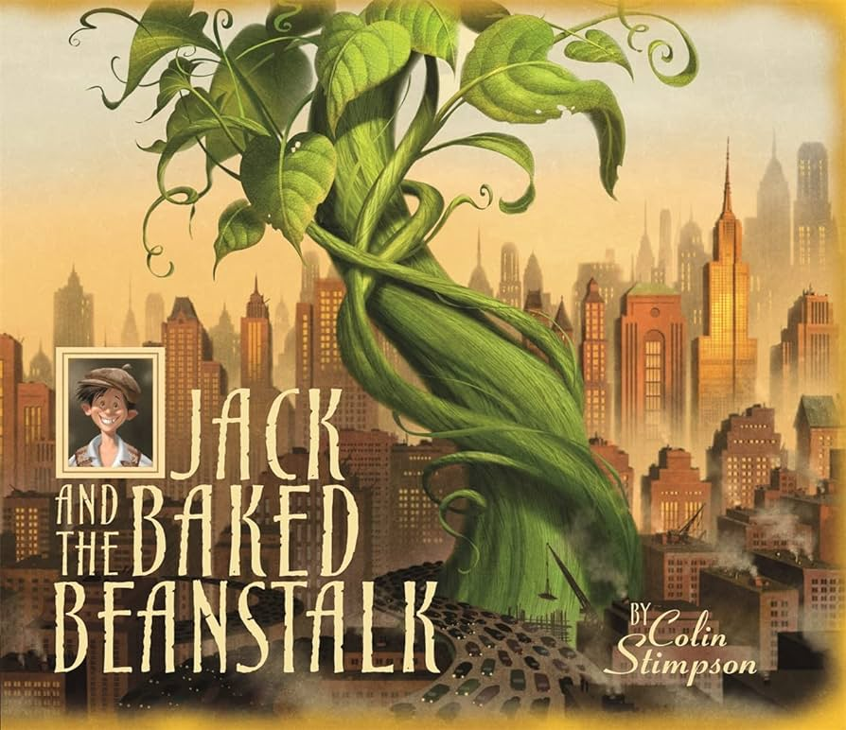  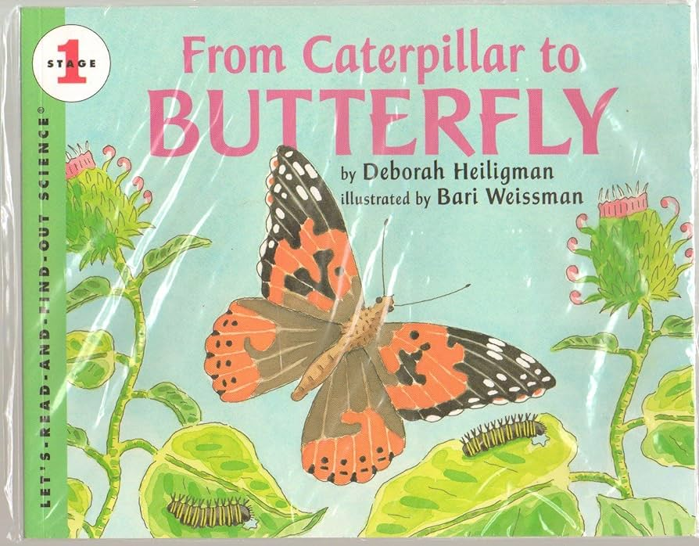  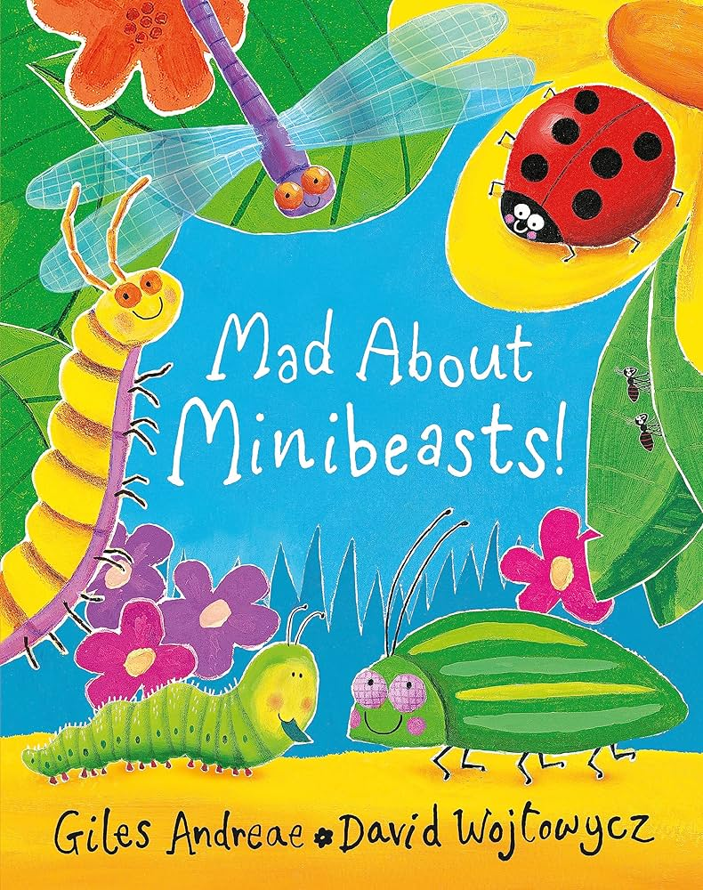 |  | Martha Maps it Out  Paddington  My Granny Went to Market  The Naughty Bus  Elephant Dance – A Journey to  India  Rumble in the Jungle  Handa’s Surprise  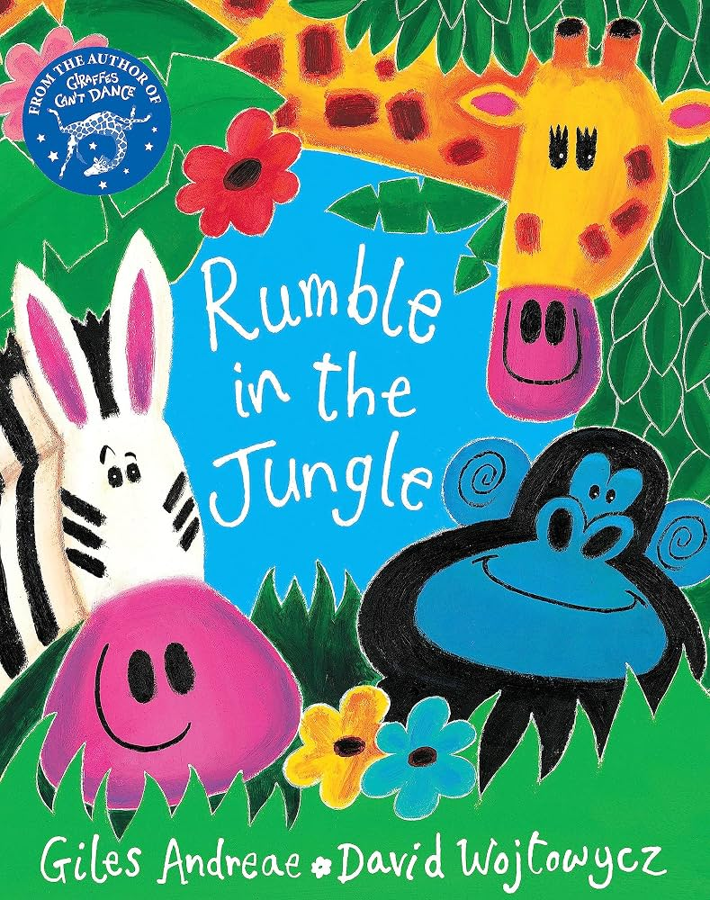  Handa’s Noisy Night  The Koala Who Could  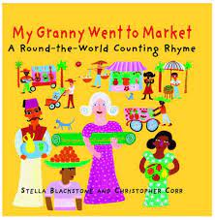  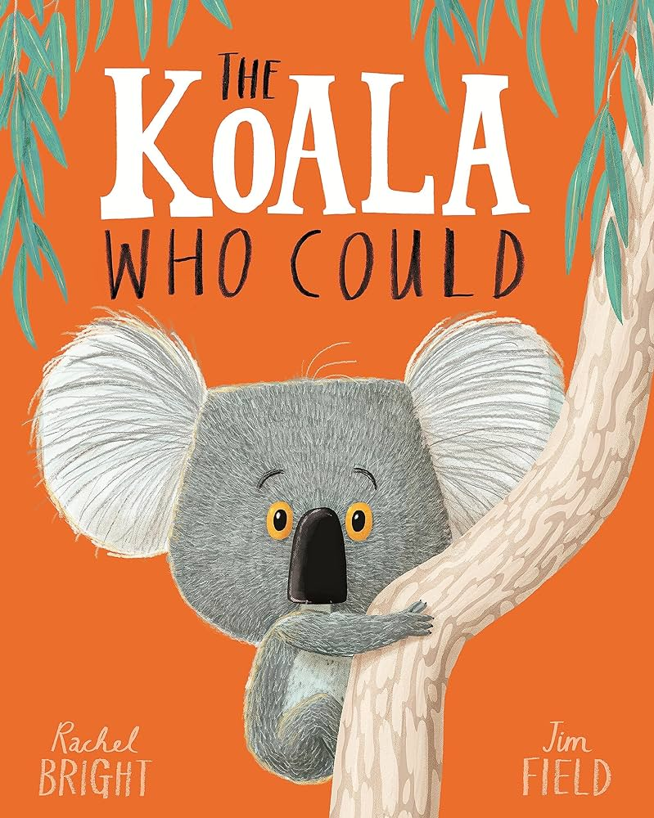  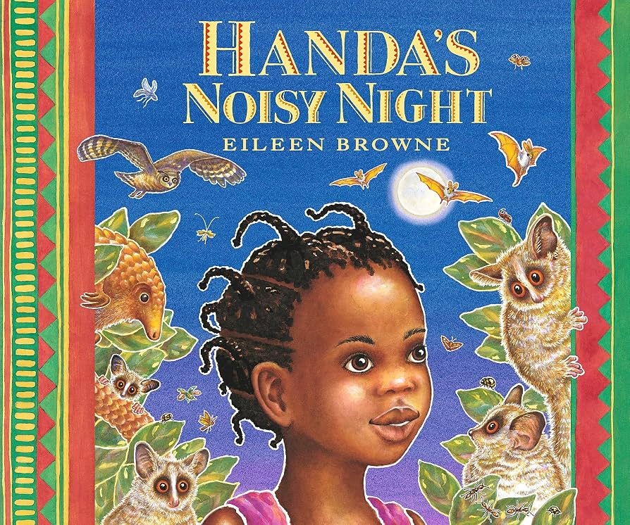  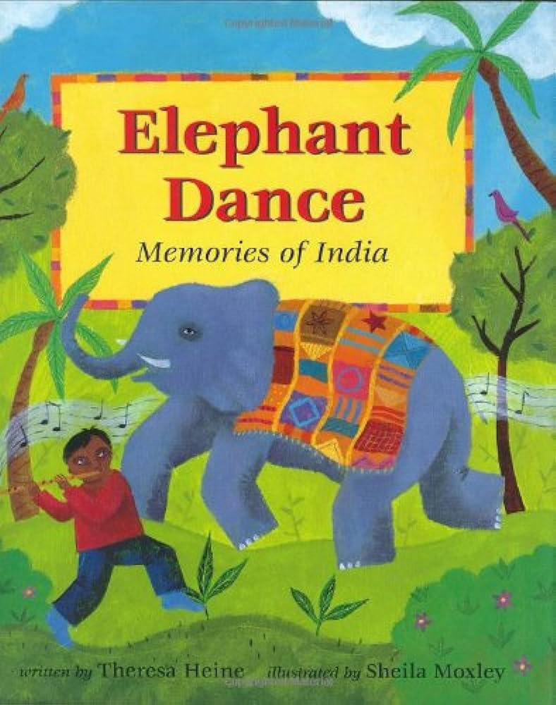  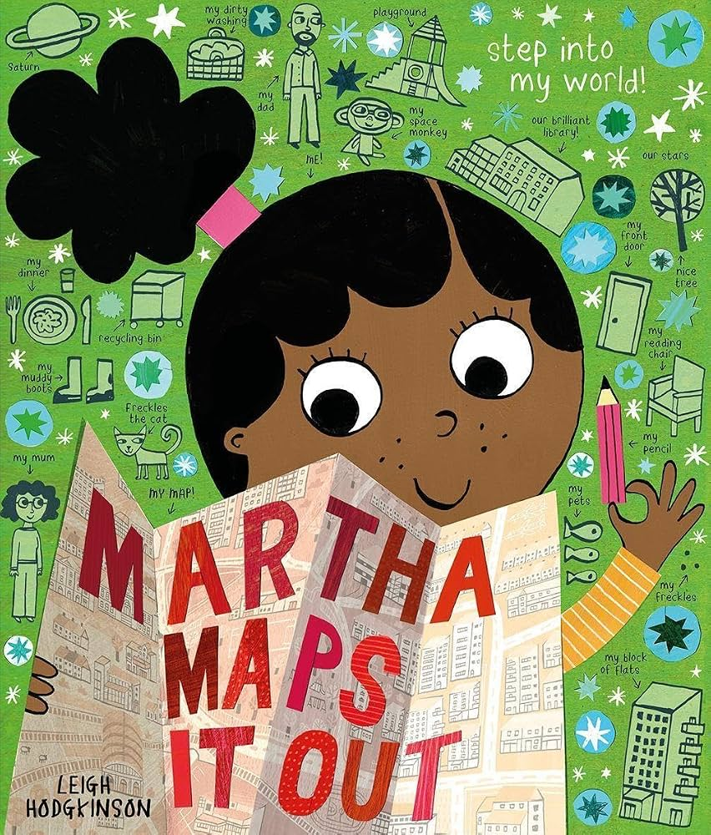
Prime Areas of Development
Physical Development (PD) | GROSS MOTOR  Continuous Provision:  Through access to gross motor equipment and activities outside during continuous provision, children will be: climbing up, jumping down, balancing, throwing, catching, running, skipping, jumping, They will be developing strength, balance and coordination when using large scale equipment. They will have access to trikes and climbing and balancing equipment.  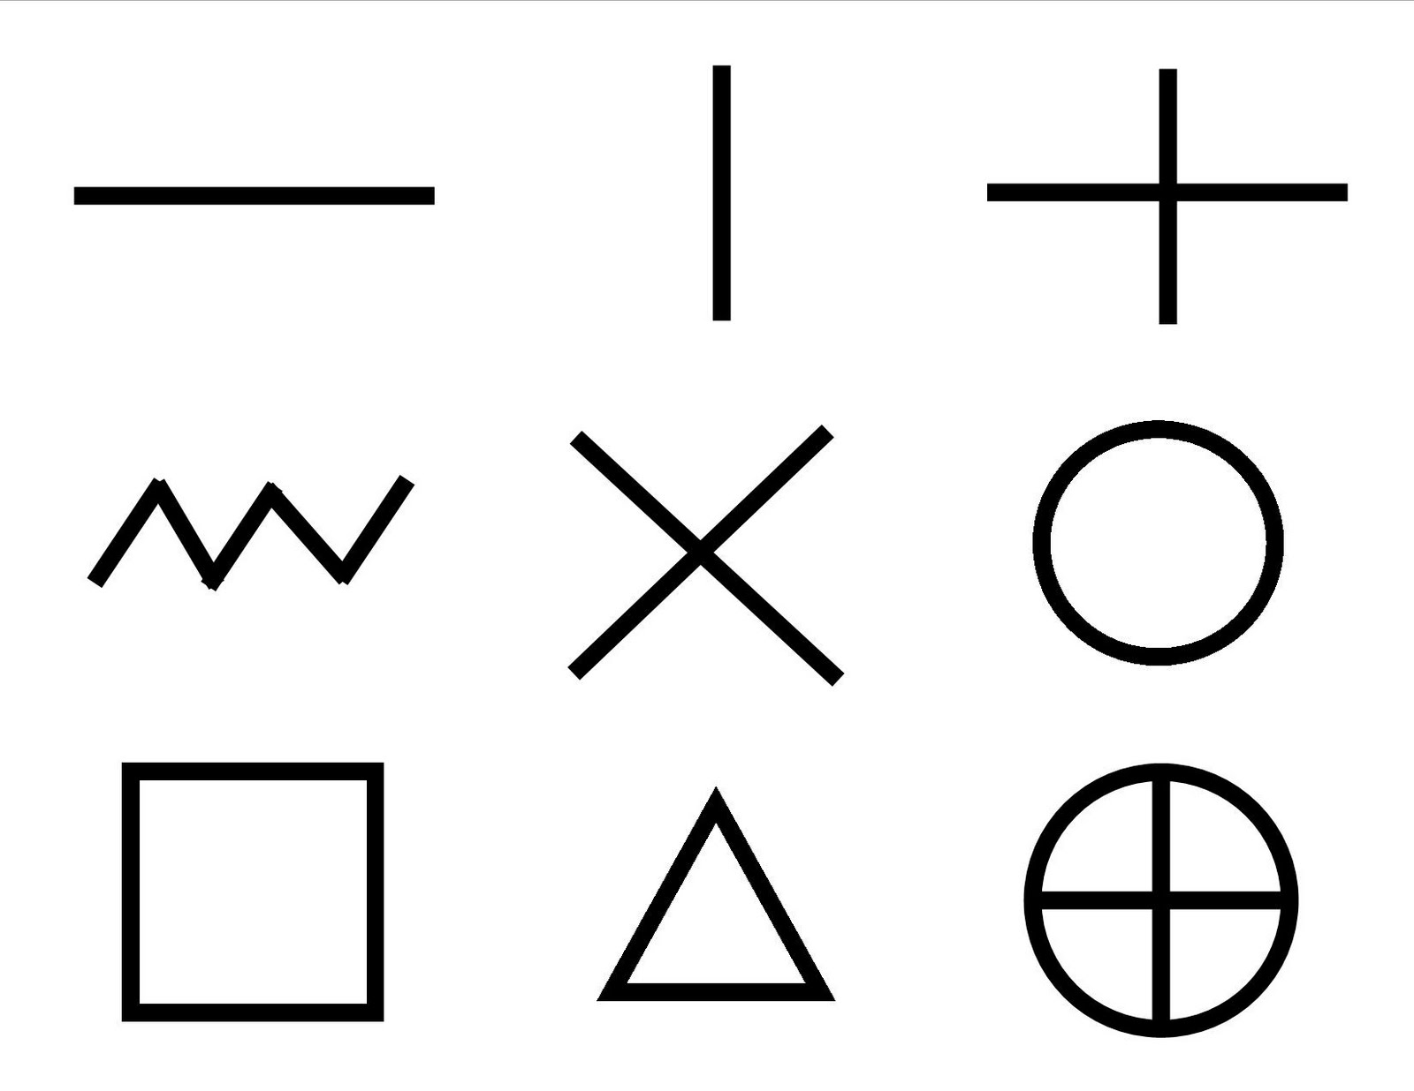  Through specifically planned activities and enhanced provision children will also develop gross motor skills through making large pre-writing shapes in various forms e.g. crayons, in the air with silks, with paint, shaving foam, brushes with water etc.  In PE:  Children will revise and refine the fundamental movement skills they have already acquired: - rolling - crawling - walking - jumping - running - hopping - skipping – climbing  Children will further develop and refine a range of ball skills including: throwing, catching, kicking, passing, batting, and aiming.  Children will use their core muscle strength to achieve a good posture when sitting at a table or sitting on the floor.  FINE MOTOR  Continuous Provision:  Children will have constant access to different tools to improve coordination and finger/hand strength for fine motor development, including mark making materials such as pencils, paint brushes, felt tips, fine tip pens, dabbers, other small craft tools such as scissors and hole punchers and tools such as playdough squeezers, cutters and clay tools. They will also have regularly enhanced fine motor provision which includes necessity to squeeze and press and coordinate, including use of tweezers, pipettes, threading beads, pegging, cutting and much more.
Physical Development (PD) | GROSS MOTOR  Children will be:  Engaging in PE lessons developing the Fundamental Movement skills.  Using large scale equipment in continuous provision.  FINE MOTOR  Children will be:  Manipulating playdough during Dough Disco  Making large and small movements with silks and mark making materials during Squiggle While You Wiggle.  Using small tools as stated above during continuous provision.  Learning to mark make simple drawings  Year1 – PE PROGRESSION SCHEME | GROSS MOTOR  Children will be:  Engaging in PE lessons developing the Fundamental Movement skills.  Using large scale equipment in continuous provision.  FINE MOTOR  Children will be:  Manipulating playdough during Dough Disco  Making large and small movements with silks and mark making materials during Squiggle While You Wiggle.  Holding a pencil to write their name and begin to form taught letters.  Using small tools as stated above during continuous provision.  Using tools on our wood work bench such as hammers, screwdrivers.  Learning to mark make simple drawings |  | GROSS MOTOR  Children will be:  Engaging in PE lessons developing the Fundamental Movement skills.  Using large scale equipment in continuous provision.  FINE MOTOR  Children will be:  Working on correct pencil grip  Developing correct technique when handwriting, working through letter families including ladder letters, curly caterpillar letters and robot arm letters.  Using small tools as stated above during continuous provision.  Learning to mark make simple drawings |  | GROSS MOTOR  Children will be:  Engaging in PE lessons developing the Fundamental Movement skills, progressing towards a more fluent style of moving, with developing control and grace.  Using large scale equipment in continuous provision.  FINE MOTOR  Children will be:  Working on correct pencil grip  Developing correct technique when handwriting, working through letter families including ladder letters, curly caterpillar letters and robot arm letters.  Using small tools as stated above during continuous provision.  Learning to mark make simple drawings |  | GROSS MOTOR  Children will be:  Engaging in PE lessons developing the Fundamental Movement skills, further developing and refining a range of ball skills including: throwing, catching, kicking, passing, batting, and aiming.  Using large scale equipment in continuous provision.  FINE MOTOR  Children will be:  Working on correct pencil grip  Developing correct technique when handwriting, working through letter families including ladder letters, curly caterpillar letters and robot arm letters.  Using small tools as stated above during continuous provision.  Learning to mark make simple drawings. | Gross Motor Skills ELG:  Negotiate space and obstacles safely, with consideration for themselves and others;  Demonstrate strength, balance and coordination when playing;  Move energetically, such as running, jumping, dancing, hopping, skipping and climbing.  Fine Motor Skills ELG:  Hold a pencil effectively in preparation for fluent writing – using the tripod grip in almost all cases;  Use a range of small tools, including scissors, paint brushes and cutlery;  Begin to show accuracy and care when drawing.
Ongoing throughout the year
- Know and talk about the different factors that support overall health and wellbeing:- regular physical activity- healthy eating- tooth brushing- sensible amounts of ‘screen time’- having a good sleep routine - being a safe pedestrian
-Further develop the skills they need to manage the school day successfully: - lining up and queuing – mealtimes - personal hygiene.
Personal, Social and Emotional Development (PSED) | PSED Principles underpin daily classroom practice which ensures all aspects of developing PSED are covered. Observations and next steps are central to supporting children in making relationships, developing self-confidence and having an awareness and managing feelings and behaviour.  Self Regulation  -See themselves as a valuable individual.  --Identify and moderate their own feelings socially and emotionally.  Self-Regulation ELG  Children at the expected level of development will:  Show an understanding of their own feelings and those of others, and begin to regulate their behaviour accordingly;  Set and work towards simple goals, being able to wait for what they want and control their immediate impulses when appropriate;  Give focused attention to what the teacher says, responding appropriately even when engaged in activity, and show an ability to follow instructions involving several ideas or actions.  Managing Self  -Manage their own needs.  -Express their feelings and consider the feelings of others  - Show resilience and perseverance in the face of challenge.  Managing Self ELG  Children at the expected level of development will:  Be confident to try new activities and show independence, resilience and perseverance in the face of challenge;  Explain the reasons for rules, know right from wrong and try to behave accordingly;  Manage their own basic hygiene and personal needs, including dressing, going to the toilet and understanding the importance of healthy food choices.  Building Relationships  -Build constructive and respectful relationships.  -Think about the perspectives of others.  Building Relationships ELG  Children at the expected level of development will:  Work and play cooperatively and take turns with others;  Form positive attachments to adults and friendships with peers;  Show sensitivity to their own and to others’ needs.
PHSE Coram | All About Me  Bouncing Back  Changes  Kindness and Caring  Listening to my Feelings  My Feelings | Different Families and Homes  Keeping my Body Safe |  | Looking after Money  My Special People  People Who Help Keep me Safe |  | Caring for my Environment  Life Stages |  | Changing Bodies  Exercise and Sleep  Healthy Eating  Looking After myself and my Friends | Same and Different
Communication and Language (C&L)  English | All aspects of developing Communication and Language are considered throughout daily classroom practice, continuous provision, group time, Guided Reading sessions and weekly directed learning. Observations, next steps and target setting support the development of individual pupils. Interventions such as the Wellcomm programme and differentiated group times are designed to support children who are not making a good level of development.  Listening, Attention and Understanding:  Understand how to listen carefully and why listening is important.  Learn new vocabulary.  -Ask questions to find out more and to check they understand what has been said to them  -Connect one idea or action to another using a range of connectives.  -Engage in story times  -Listen to and talk about stories to build familiarity and understanding.  -Retell the story, once they have developed a deep  familiarity with the text; some as exact repetition and some in their own words.  -Listen carefully to rhymes and songs, paying attention to how they sound.  - Learn rhymes, poems and songs.  -Engage in non-fiction books.  -Listen to and talk about selected non-fiction to develop a deep familiarity with new knowledge and vocabulary.  Listening, Attention and Understanding ELG  Children at the expected level of development will:  Listen attentively and respond to what they hear with relevant questions, comments and actions when being read to and during whole class discussions and small group interactions;  Make comments about what they have heard and ask questions to clarify their understanding;  Hold conversation when engaged in back-and-forth exchanges with their teacher and peers.  Speaking  -Learn new vocabulary  Use new vocabulary through  the day  -Articulate their ideas and thoughts in well-formed sentences.  -Describe events in some detail.  -Use talk to help work out problems and organise thinking and activities, and to explain how things work and why they might happen.  -Develop social phrases  -Use new vocabulary in different contexts.  Speaking ELG  Children at the expected level of development will:  Participate in small group, class and one-to-one discussions, offering their own ideas, using recently introduced vocabulary;  Offer explanations for why things might happen, making use of recently introduced vocabulary from stories, non-fiction, rhymes and poems when appropriate;  Express their ideas and feelings about their experiences using full sentences, including use of past, present and future tenses and making use of conjunctions, with modelling and support from their teacher.
Communication and Language (C&L)  English | Talk about their likes/dislikes.  Talk about themselves and their family  Speak in a full sentence Listening and Attention  Focus on an activity for a short period of time. | Speaking skills.  Use language to communicate and explain how they are feeling and what they want to do.  Talk in simple sentences |  | Listen and respond to stories with increasing attention. |  | Following instructions and re-calling instructions given.  Listen and respond to peers and adults. |  | Speaking skills.  Organise talk and sequence ideas together to express opinions about their interests. | Answering ‘how’ and ‘why’ questions.  Listen to others opinions.
Specific Areas of Development
 | Autumn 1 | Autumn 2 | Spring 1 |  | Spring 2 |  | Summer 1 |  | Summer 2
Literacy  Red Rose Phonics | Phase 2  Recognising letters and the sounds they make.  Segmenting and blending simple CVC words.  Recognising HFW  Phase 3  Year 1 Phase 3  The children will build on from phase 2  Learn single letter graphemes  , diagraphs and trigraphs  Reading and spelling tricky words  Segment and blend CVCC,CCVC and CCVCC words | Phase 2  Segmenting and blending CVC and CCVC words.  Spelling simple VC, CVC and CCVC words using phonics knowledge.  Recognising and spelling HFW.  Phase 3  Year 1 Phase 3  The children will build on from phase 2  Learn single letter graphemes  , diagraphs and trigraphs  Reading and spelling tricky words  Segment and blend CVCC,CCVC and CCVCC words |  | Phase 3  Learning graphemes.  Segmenting and blending phase 3 words using phonic knowledge.  Read simple sentences.  Recognising and spelling key HFW.  Phase 3  Year 1 Phase 3  The children will build on from phase 2  Learn single letter graphemes  , diagraphs and trigraphs  Reading and spelling tricky words  Segment and blend CVCC,CCVC and CCVCC words |  | Phase 3  Reading sentences using letters and sounds to decode unfamiliar words.  Recording sentences with key HFW and use of phonic knowledge.  Phase 4  Move onto phase 4 to consolidate phase 3, using and applying strategies. |  | Phase 3 Consolidation  Re-capping what has been taught.  Using and applying strategies through reading and writing.  Phase 4  Move onto phase 4 to consolidate phase 3, using and applying strategies. | Phase 4  Move onto phase 4 to consolidate phase 3, using and applying strategies.  Word Reading ELG  Children at the expected level of development will:  Say a sound for each letter in the alphabet and at least 10 digraphs;  Read words consistent with their phonic knowledge by sound-blending;  Read aloud simple sentences and books that are consistent with their phonic knowledge, including some common exception words  Year 1 Fast Track phonics programme / Phase 5
 | Autumn 1 | Autumn 2 |  | Spring 1 |  | Spring 2 |  | Summer 1 | Summer 2
Maths  Red Rose Maths | Routines – days of the week, date, first, next, after  Matching objects.  Sorting objects.  Comparing amounts.  Counting out loud.  Comparing size, mass and capacity.  Making simple patterns. | Composition of 1,2,3.  Representing and comparing 1,2,3.  Understanding equal and not equal.  Addition within 3.  Introduce and explore 4 and 5.  Shapes – circles, triangles, squares, rectangles.  Positional Language.  Subtraction within 5.  1 more/1 less within 5.  Time – night and day. |  | Introducing 0.  Comparing numbers to 5.  Composition of 4 and 5.  Making pairs.  Addition and subtraction (one more one less)  Measuring and comparing mass and capacity.  Introducing 6,7,8.  Counting, subitising, comparing, composition of 6,7,8.  Combining two groups and adding more.  Subitising on a dice.  Doubles.  Describing and comparing length and height.  Time – Days of the week. |  | Composition of, sorting, comparing 9 and 10.  Ordering numbers.  Partitioning and combining (as inverse)  Counting forwards and backwards.  Rhymes to 10.  Bonds to 10  3D shape names and properties (curved, flat)  Patterns. |  | Number patterns to 20.  Visual representations of numbers to 20.  Beyond 20 on tens frame.  Using number lines to count.  Ordering numbers and identifying missing numbers.  Estimating  Adding more  Taking away  Matching, rotating and manipulating shape.  Composing and decomposing shapes | Doubling  Sharing and grouping  Odd and Even  Replicating models and patterns  Problem solving  Investigating links between number and shapes  Map work  Revisiting previous learning  Number ELG  Have a deep understanding of number to 10, including the composition of each number;  Subitise (recognise quantities without counting) up to 5  Automatically recall (without reference to rhymes, counting or other aids) number bonds up to 5 (including subtraction facts) and some number bonds to 10, including double facts.  Numerical Patterns ELG  Verbally count beyond 20, recognising the pattern of the counting system;  Compare quantities up to 10 in different contexts, recognising when one quantity is greater than, less than or the same as the other quantity;  Explore and represent patterns within numbers up to 10, including evens and odds, double facts and how quantities can be distributed equally
Understanding the World (UW) | People, Culture and Communities:  - Talk about family and people in both school community and outer community  - Location of school within community, including aerial view and mapping  - Visits within the community  - Visit to church for Harvest festival  Past and Present:  - Children know that we change as we grow and that the time when we were babies is in the past, using photographs from their past.  The Natural World  - Children know about similarities, differences, pattern and change in relation to people.  - Using senses when exploring outside (see, hear and feel) including experiencing different weather conditions.  - Talk about changes in autumn – leaves changing colour and falling from trees.  - Noticing the different weather daily including cooler in Autumn.  Use a range of maps and globes (including picture maps) at different scales.  Know that maps give information about places in the world (where/what?).  Locate land and sea on maps.  Enquiry and Investigation  Ask simple geographical, ‘where?’, ‘what?’, and ‘who?’ questions about the world.  Recognise differences between their own and others’ lives.  Communication  Speak and write about, draw, observe and describe simple geographical concepts.  Use basic geographical vocabulary.  Use of ICT/Technology  Use simple electronic globes/maps.  Use the zoom facility of digital maps and understand that zooming in/out means more/less detail can be seen. | People, Culture and Communities  - Showing awareness of differences and similarities between groups from around the world including looking at multicultural festivals of light including Diwali.  - Learn about Diwali as a Hindu festival, including the story of Rama and Sita.  - Children attend church service for Christmas. Children learn that Christmas is a special event from the Christian Bible.  Past and Present:  - Children learn about Guy Fawkes and the story of the Gunpowder Plot.  - Children remember those lost in WW1 and WW2 during learning about remembrance day.  - Compare and contrast characters from stories, including figures from the past.  The Natural World:  - Talk about changes in autumn (that they see, hear, feel when outside) – evergreen vs deciduous trees and their changes during seasons.  - Notice changes in weather from Autumn to Winter.  - Children name some UK animals which hibernate  - Children explore with torches to make different shadows and colours |  | People, Culture and Communities:  - Children draw simple maps of imaginary settings from stories they know well e.g. Three Billy Goats Gruff  - Children note changes in the weather and season. (Winter)  - Children discuss the features of contrasting cold places (Arctic and Antarctic)  - Children recognise some similarities and differences between life in this country and life in the Arctic/Antarctic.  - Children learn about Lunar New Year celebrations.  Past and Present:  - Children learn about celebrations such as Eid and Lunar New Year  - Children compare and contrast characters from traditional tales and stories and know these were set in the past. Children discuss how their lifestyle compares to ours (past vs present).  The Natural World:  - Share stories which explore materials such as The Three Little Pig’s houses and The Princess and the Pea’s bed.  - Children talk about changes in the weather and environment in winter, discussing what they see/feel/hear when outside.  - Children talk about animals which live in cold places (while looking at Arctic/Antarctic).  - Children explore the properties of ice and changing states of matter.  . |  | People, Culture and Communities:  - Children talk about animals that live by the sea and in the sea.  - Children draw simple maps of imaginary settings from stories they know well e.g. The Troll  - Children draw information from simple maps, follow maps and make maps from 3D representations.  - Children learn about special cultural and religious celebrations including Easter and Holi  Past and Present:  - Children learn that pirates were real and learn about some famous pirates (including Blackbeard)  - Children discover some old, real shipwrecks such as the Titanic.  The Natural World:  - Exploring floating and sinking and creating objects which float (sorting floating and sinking objects, and creating own floating objects), and considering the effect of adding weight (like passengers!) to the buoyancy of boats.  - Children learn about the famous scientist Archimedes through the story Mr Archimedes Bath.  - Children learn about seasonal changes in Spring, including naming Spring flowers |  | People, Culture and Communities:  - Making simple maps of our outdoor environment and garden.  - Children learn about Eid as a celebration for Muslim people within our community.  Past and Present:  - Children learn about significant figures from the past and present linked to art, such as Vincent Van Gogh.  The Natural World:  - Children describe their environment, focusing on new Spring/Summer environmental changes (flowers, buds).  - Name parts of a plant.  - Know what a plant needs to grow.  - Know about the life cycle of a butterfly.  - Learn to care for the natural environment and all living things.  - Know the food items which are grown.  - Explore the features of our school environment. Take photographs and draw pictures of plants and animals. | Cultures, People and Communities:  - Children describe their immediate environment – learning about Clitheroe and features of our town.  - Children compare contrasting environments, sharing photographs of holiday locations and their own experiences.  - Children consider cultural and lifestyle differences in different countries around the world.  - Children learn how to look after their local environment, including recycling and litter picking (on school grounds).  Past and Present:  - Children to compare images from the past of local significance including Clitheroe castle and town.  The Natural World:  - Children describe their environment, focusing on new Spring/Summer environmental changes (flowers).  - Children learn about animals in other countries.  - Children explore water and it’s states, what happens to it over time, what happens when colours are splashed on to it, what happens when salt is added to it etc.  Past and Present ELG  Talk about the lives of the people around them and their roles in society;  Know some similarities and differences between things in the past and now, drawing on their experiences and what has been read in class;  Understand the past through settings, characters and events encountered in books read in class and storytelling;  People Culture and Communities ELG  Describe immediate environment using knowledge from observation, discussion, stories, non-fiction texts and maps;  Know some similarities and differences between different religious and cultural communities in this country, drawing on their experiences and what has been read in class;  Explain some similarities and differences between life in this country and life in other countries, drawing on knowledge from stories, non-fiction texts and – when appropriate – maps.  The Natural World ELG  .
Expressive Arts and Design (EAD) | Creating with materials  -Create collaboratively, sharing ideas, resources and skills.  Being Imaginative and Expressive  Listen attentively, move to and talk about music, expressing their feelings and responses.  - Develop storylines in their pretend play.  Self-Portraits  Stick man/Saws  Autumnal painting – colour mixing  Singing lots of songs and familiarising children with regular singing.  Leaf rubbings  Sand and Water  Mud  Nursery rhymes  Music man instruments  Role play  Music and emotion  Junk modelling  Woodwork, drill, hammer  Year 1  Drawing  Experiment with a variety of media; pencils, rubbers, crayons, pastels, felt tips, charcoal, ballpoints, chalk.  Control the types of marks made with the range of media.  Observe and draw shapes from observations.  Invent new shapes ( e.g. icebergs).  Investigate tone by drawing light/dark lines, light/dark shapes.  Painting  Use a variety different brush sizes and types.  Mix and match colours to objects.  Work on different scales.  Name different types of paint and their properties; e.g. watercolours/ready mix.  Identify primary and secondary colours by name.  Mix primary shades and tones.  3-d Clay  Manipulate malleable materials in a variety of ways including rolling and kneading.  Manipulate malleable materials to make a sculpture.  Change the surface of a malleable material.  Understand the safety and basic care of materials and tools.  Evaluating  Review what they and others have done and say what they think and feel about it.  Identify what they might change in their current work or develop in future work. | Being Imaginative – Music focus  Explore, use and refine a variety of artistic effects to  express their ideas and feelings.  - Watch and talk about dance and performance art,  expressing their feelings and responses.  - Develop storylines in their pretend play.  - Explore and engage in music making and dance, performing solo or in groups  Bonfire night paints and textures.  Christmas cards  Calendars  Christmas craft, cards and decorations.  Firework sounds/instruments  Act out Guy Fawkes  Fork scratch hedgehogs  Pumpkin paint  Christmas songs  Using role-play to act out  Hot colours/cold colours  Snowflake cutting  Snowflake Printing  Snowmen collage  Snowmen bottles  ICT Rudolph  Christmas crowns  Christmas cards  Painting with ice  Ice sculptures  Charcoal  Glass paint  Year 1  Drawing  Experiment with a variety of media; pencils, rubbers, crayons, pastels, felt tips, charcoal, ballpoints, chalk.  Control the types of marks made with the range of media.  Observe and draw shapes from observations.  Invent new shapes ( e.g. icebergs).  Investigate tone by drawing light/dark lines, light/dark shapes.  Painting  Use a variety different brush sizes and types.  Mix and match colours to objects.  Work on different scales.  Name different types of paint and their properties; e.g. watercolours/ready mix.  Identify primary and secondary colours by name.  Mix primary shades and tones.  3-d Clay  Manipulate malleable materials in a variety of ways including rolling and kneading.  Manipulate malleable materials to make a sculpture. |  | Being Imaginative – use other cultures / hot and cold to Explore, use and refine a variety of artistic effects to  express their ideas and feelings.  - Watch and talk about dance and performance art,  expressing their feelings and responses.  - Sing in a group or on their own, increasingly matching the pitch and following the melody  - Develop storylines in their pretend play.  - Explore and engage in music making and dance, performing solo or in groups. (Play music with a pulse for children to move in time with and encourage them to respond to changes: they could jump when the music suddenly becomes louder, for example.)  Winter art – using wax crayons and watercolours  Winter collages  Story characters  Dough biscuits  Mother’s Day cards  Feltmaking  Dance/Chinese dragon |  | Creating with Materials  - Return to and build on their previous learning, refining  ideas and developing their ability to represent them. (Teach children different techniques for joining  materials, such as how to use adhesive tape and  different sorts of glue).  Easter craft  Splatter for Holi  Scale and collaboration  print  colour mixing  photography |  | Painting supertato  Making super veg  Designing prison/escape  Printing with veg  Butterfly paintings  Butterfly print/symmetry  Using natural materials to create pictures.  Bubble print  Woodwork frogs | Creating with Materials ELG  Safely use and explore a variety of materials, tools and techniques, experimenting with colour, design, texture, form and function;  Share their creations, explaining the process they have used;  Make use of props and materials when role playing characters in narratives and stories.  Being Imaginative and Expressive ELG  Invent, adapt and recount narratives and stories with peers and their teacher;  Sing a range of well-known nursery rhymes and songs;  Perform songs, rhymes, poems and stories with others, and – when appropriate – try to move in time with music.  Fingerpuppets sewing  Joining  Design and make process  Collage  Levers  Scale mosque architecture  Colour matching
EAD  Music | Charanga  Me!  - Children listen and respond to pieces of music or songs in different styles, moving to the music.  - Children explore and create using voices and instruments considering pulse, rhythm and pitch  - Children sing nursery rhymes and action songs  - Children share and perform  EYFS CHILDREN ASO JOIN KS1 FOR MUSIC USING KAPOW | Charanga  My Stories  - Children listen and respond to pieces of music or songs in different styles, moving to the music.  - Children explore and create using voices and instruments considering pulse, rhythm and pitch  - Children sing nursery rhymes and action songs  - Children share and perform |  | Charanga  Everyone  - Children listen and respond to pieces of music or songs in different styles, moving to the music.  - Children explore and create using voices and instruments considering pulse, rhythm and pitch  - Children sing nursery rhymes and action songs  - Children share and perform |  | Charanga  Our World  - Children listen and respond to pieces of music or songs in different styles, moving to the music.  - Children explore and create using voices and instruments considering pulse, rhythm and pitch  - Children sing nursery rhymes and action songs  - Children share and perform |  | Charanga  Big Bear Funk  - Children listen and appraise  - Children learn about interrelated dimensions of music through singing, improvising and playing instruments  - Children perform and share | Charanga  Reflect, Rewind and Replay  - A consolidation of the year’s work  - Children prepare for a performance  - Childrne look at the history of music.
ICT | Ongoing as appropriate:  ICT whiteboard games, ipad games, taking photographs, using search (adult), drawing apps, writing apps, Google streetview, Google Earth, Youtube videos, maps, music, dance, programmable toys.  All with an emphasis on keeping safe online

Parental engagement | Visit our classroom  Stay for Lunch  Send wow cards and photos  Macmillan coffee morning  Learning journey share  Weekly email  Autumn Outdoor Family Challenges | Parent meetings  Learning journey share  Send wow cards and photos  Weekly email  Winter Outdoor Family Challenges | Learning journey share  Send wow cards and photos  Weekly email | Learning journey share  Send wow cards and photos  Weekly email  Spring Outdoor Family Challenges | Parent meetings  Learning journey share  Send wow cards and photos  Weekly email  Summer Outdoor Family Challenges | Transition meetings / home visits  Come and Play  Reports  Weekly email
Assessment | My baseline assessments  Gov baseline assessments  Phonics tracking | My tracker  Pupil Progress meetings |  | My tracker  Pupil Progress meetings | EYFS Profile  Data analysis  Moderation | My Tracker  Pupil progress meetings  Transition to Year 1

