Brennand’s

Forest School Handbook

Contents

Brennand’s Forest School 3

The Forest School Ethos 3

Background to the Brennand’s Forest School 4

Our Forest School Leaders & Volunteers 5

Our Forest School Location 6

Our Forest School Sessions 7

Equality in our Forest School 8

Health & Safety 8

Our Health & Safety Policy 8

Emergency & Serious Incident Procedure 11

Tool Use 13

Fire Procedure 14

Out of control fire procedure 14

Lost or Missing Child 15

Safeguarding 16

Toileting 17

Food Hygiene and Eating 17

Conservation 18

Communication 19

Appendices 20

A: Risk Assessments 20

Brennand’s Forest School Risk Assessment: Blank 20

Brennand’s Forest School Risk Assessment: Site Sweep - blank 21

B: Lesson Plan: blank 22

C: Tool Maintenance Schedule 24

D: Environmental Management Plan 26

E: Environmental Impact Assessment 27

F: Brennand’s Behaviour Policy 28

G. Brennand’s Equality Policy 30

H: Brennand’s Medication Policy 32

Please sign to confirm you have read this Handbook… 34

Review schedule 34

Attached Files 35

🞏 Forest School Qualification(s) 35

🞏 First Aid Certificate(s) 35

🞏 DBS Certificate(s) 35

🞏 Food Hygiene Certificate(s) 35

🞏 Insurance 35

# Brennand’s Forest School

## The Forest School Ethos

*Forest School has been defined as:*

*“an inspirational process that offers ALL learners regular opportunities to achieve and develop confidence and self-esteem through hands-on learning experiences in a woodland or natural environment with trees”*

*(www.forestschoolassociation.org)*

*Forest Schools have six key principles:*

* Forest School is a long-term process, encompassing regular sessions (ideally across all the seasons) and embracing a cycle of planning, adapting, observing and reviewing.
* Forest School takes place in a natural wooded environment with the aim of creating a relationship between learners and nature, using natural materials and positive outdoor experiences to encourage learner driven exploration. Forest School also monitors its environmental impact and works to a long term environmental management plan to ensure good working practices and a sustainable site.
* Forest School encourages activities which promote all elements of holistic development, fostering resilient, confident, independent and creative learners, and linking activities to the indoor classroom where appropriate.
* Forest School offers the opportunity for learners to take appropriate and supported risks, using fire and tools only where appropriate to the learners, and using a Risk Benefit analysis to inform choices relating to risk.
* Forest School is run by Level 3 Forest School qualified practitioners who embrace continuous professional development and, being reflective, also see themselves as learners. Leaders also hold outdoor first aid certification. The adult to learner ratio is high and the Forest School is supported by a relevant handbook detailing policies, procedures, roles and responsibilities.
* Forest School creates a community for learning using a range of learner-centred approaches and suited to all learning preferences. Learners are encouraged to play, make choices for themselves and reflect on their achievements, developing emotional intelligence and self-esteem.

*Forest Schools bring a wealth of benefits for learners including:*

* Positive outdoor experiences
* An understanding of the importance of boundaries, both physical and social
* An appreciation of natural materials
* How to assess and manage risk
* Freedom to choose activities during free play sessions and an option to repeat these activities week after week
* How to use tools appropriately and safely
* An appreciation and respect for our natural world
* Building of confidence and self-esteem through small achievable tasks
* … and many more…!

## Background to the Brennand’s Forest School

Once upon a time there were three Sarahs who all went on a Forest School adventure to a nearby school to find out what all the excitement was about. They took with them as many KS2 children as they could fit into one shiny minibus along with a bag full of tasty snacks and enough wellies to go around.

Arriving at their foresty destination it didn’t take the three of them long to see how much the children enjoyed the fresh air, freedom and fun abundantly available in the big outdoors (even though some of their challenges were a little bit dangerous!) and they began to hatch a plan to bring this magical Forest School idea back home to Brennand’s as soon as ever they could.

Before long they had gathered the wisdom and tools they would need to create their very own Forest School in the perfect spot to share with all their children, so that they too could experience the magic and danger of the forest in all its glory.

Since then there has been many developments and changes in staff, but the magic continues…….

## Our Forest School Leaders & Volunteers

Our current Forest School Leaders:

**Sarah Snape** – “I’ve been volunteering with Brennand’s as a classroom assistant for nearly two years now ever since my own son left there for high school; I was particularly impressed with the school and teachers and the positive impact it had on Ol’s confidence, and I wanted to continue supporting the school. I first came across Forest School when Ol was about 8 years old and remember thinking how wonderful it was to encourage children to explore, play and take risks in the truly great outdoors, all the while building their self-awareness and interpersonal skills. I’m passionate about being outside, about the environment and about self-belief…. As such I’m hugely excited to have the opportunity to be involved in this venture. My work background has given me a fabulous mix of creative and organisational skills to add to my love of all things green and growing, and my more recent experience working in the classroom has felt like the final piece of the puzzle preparing me for this new role as a Forest School Leader!” Jan 2018

**Helen Murray** – “ I was won over to the Forest School way by the enthusiasm and passion shown by the Sarahs and by witnessing the positive experience Forest School sessions had on the children in the school. They loved being outdoors and having the opportunity to explore and learn on their own terms and at their own pace.

As a primary school teacher with many years of classroom teaching, it was refreshing to let go of set ways of working and revisit different learning styles and methods. When the opportunity arose to train as a Forest School Leader I grasped it with both hands and I am looking forward to working alongside Sarah, to continue to build the Forest School Experience at Brennand’s.” October 2020

Our Forest School Leaders are trained to Level 3 standard and allowed time for continuous professional development to ensure our Forest School Programme is delivered competently and evolves with the skills of the Leaders. Forest School Assistants will be trained to Level 1 and similarly encouraged to develop their skills and experience.

All Forest School volunteers will receive comprehensive guidance from the Leaders including Forest School ethos, H&S briefing and introduction to the learners.

All Forest School staff will be protected by and subject to the HR policies and procedures of Brennand’s Endowed Primary School including but not limited to grievance procedure, complaints, employment.

Roles & Responsibilities

|  |  |  |
| --- | --- | --- |
|  | Role | Responsibilities |
| Forest School Leader | * plan, lead and evaluate Forest School sessions * observe learners, allowing independent play as much as possible | * create, adhere to and share Forest School handbook including policies & procedures * write risk assessments and share with all staff |
| Forest School Assistant | * assist the leader as needed * observe learners, allowing independent play as much as possible | * adhere to Forest School handbook |
| Volunteer | * assist the leader as needed and where qualified * observe learners, allowing independent play as much as possible | * adhere to Forest School handbook |

## Our Forest School Location

Our School Area is located at the far end of our school playing field, making it easy to access as well as being familiar to our learners. Within our space we have a willow dome, a large grassy area, a pond and a few young trees. A green path has been laid to allow disabled access. Work is soon to start on a permanent fire-pit and tarp friendly posts. Longer term we will include more tree planting as well as searching our local area for a mature woodland to offer a contrast for our learners.

School address: Church Street, Slaidburn, Clitheroe, BB7 3ER

Phone number: 01200 446 664

Grid reference: SD7103352142

## Our Forest School Sessions

A typical Forest School session might look like this:

* Leaders to perform site sweep (an on-the-day risk assessment)
* Circle time, welcome, boundary setting
* Activity, set by leaders and adapted for / by learners
* Snack time, suited to the seasons
* Free play, regular options available
* Circle time, reflection & close
* Check for litter & depart to school

Some activities we might enjoy during our sessions:

* Fire building
* Den building
* Colour hunting
* Making clay faces
* Creating art installations
* Treasure maps
* Mini beast hunting
* Fairy doors
* *…. the list is endless!*

The activities we plan will be appropriate to the learners and observation on the day may lead to our plans changing – the sessions will be child-led so we will respond to the children; are they enjoying the session? Are they finding the tasks achievable, though not necessarily first time? If no,t we could alter the task or set up some free play. Each session will help to inform the following session, taking into account reflection from both learners and leaders.

For each Forest School session we will have the following equipment prepared and to hand:

* First aid kit
* Forest School handbook
* Fresh water
* Tools & PPE (if needed)
* Fire equipment (lighting kit, PPE, burns kit, water bucket, fire blanket) (if needed)

# Equality in our Forest School

Our aim is to ensure that all learners can experience the benefits of our Forest School and to remove any barriers that might stop this happening.

How will we do this?

* By getting to know our learners
* Finding out about any medical or learning needs
* Ensuring our site is accessible to all
* Ensuring learners are dressed appropriately (eg waterproofs and wellies) so that the weather isn’t a barrier
* Supporting different learning styles
* Recognising that learners may welcome company (teamwork) or prefer quiet time and supporting this as appropriate
* Adapting our activities and free play options based on the above
* Committing to treat all our learners fairly and as individuals regardless of ethnicity, gender, background, academic achievement, disability or age.
* Checking (through feedback from learners and each other; Forest School leaders & volunteers) that we are actually getting it right and making further changes where necessary

# Health & Safety

## Our Health & Safety Policy

Activities included within Forest Programmes may be considered higher risk than usual for child learners. Brennand’s Forest School considers the risks of all planned activities but also highlights the potential benefits for learners. In order to minimise risks, Brennand’s Forest School follows appropriately set procedures for riskier activities such as fires and tool use. Risk assessments are carried out which cover key and potential hazards that learners, forest school leaders and other adults may come in to contact with during a forest School session.

**Legislation**

Brennand’s Forest School fully accepts its legal obligations under the Health and Safety at Work Act 1974. The purpose of this act is to promote, stimulate and encourage high standards of health and safety at work. It protects not only all people at work, but also the health and safety of the general public who may be affected by the work activities such as child learners and accompanying adults.

**Staff & Training**

All our Forest School leaders hold a Level 3 qualification in Forest School Leadership and have obtained DBS checks. The Forest School leaders both hold an up to date outdoor first aid qualification. The Forest School leaders will direct and support all members of staff and volunteers to ensure all policies and procedures outlined in this handbook are followed.

**Risk / Benefit Analyses**

Brennand’s Forest School recognises that risk taking is a beneficial and important aspect of child learning and development. The Forest School works to provide a natural environment where children can learn about managing risks and challenges whilst remaining safe. The benefits and risks are considered and assessed to provide a safe learning environment. This is done through Risk/Benefit analysis of both the site and any planned activities.

**On Site Risk Assessment Procedure**

To ensure that the forest school area is kept safe and accessible, a Forest School leader will make regular visits to the site to maintain safe access routes both in and leading to the forest school area (due to learners accessing indoor toileting). Site assessments will be done prior to any activities taking place and aim to identify hazards that may cause harm. The forest school leader will identify actions or precautions that should be taken to reduce the risk factor. Dangerous items such as sharps or cans will be disposed of appropriately in a sharps box and removed off the site. All staff and volunteers will be provided with copies/access to the risk assessment and a final site sweep will be done prior to groups of learners and adults entering the site and starting activities.

The location and grid reference of the site is noted in the introduction to Brennand’s Forest School section of the handbook. This handbook will be made accessible to all staff, volunteers and visitors should they be required to attend to an incident (the leader may be injured for example). Forest School Leaders will have a mobile phone on the site and other staff and volunteers made aware of its location. There is very limited mobile coverage at the site; however Emergency calls can still be made.

Forest School leaders will be mindful of the weather forecast, as adverse or changing weather conditions can create challenges, such as falling branches, slippery floors and surfaces and excessive sun exposure. These factors will be assessed prior to and during a session and could mean that arranged activities may need to be altered.

Where final sweeps are not possible prior to groups arriving at the site, a sweep and assessment will be made with the group upon their arrival.

**Five steps to risk assessment:**

1. Check the environment and look for the hazards, such as windblown trees, fallen branches or litter

2. Identify who might be harmed and how

3. Evaluate the risks and identify precautions to be taken to reduce risks.

4. Record the findings

5. Review the assessment and revise if necessary. Decide whether existing precautions are adequate or whether more should be done

**Shared Information & Responsibility**

The activities undertaken at Brennand’s Forest School are done in partnership with Brennand’s Primary School. The role and responsibilities of adults on the site with regards to group safety are outlined in the handbook introduction and agreed upon prior to the session taking place.

As the Forest School belongs to the school, colleagues will share information regarding the learners to:

* Support pupils’ learning
* Monitor and Report on their progress
* Provide appropriate pastoral care; and
* Assess the quality of our services

Information regarding behaviour that may be a risk to individuals and/or the group and personal needs such as medication should be passed on to the Forest School leaders. Some individuals may require a separate risk assessment with behaviour management procedures to follow for example. Other personal information such as a learner’s allergies or fears are also useful information with regards to planning activities to make the session accessible and beneficial to all.

**Insurance**

The Brennand’s Forest School and its staff are insured by The Authority’s Public Liability Insurance. This will provide cover for claims regarding injury caused by a negligent act and/or damage to third party property. This cover also applies to other suitable locations belonging to the Authority. If the location belongs to another organisation or landowner then evidence of their Public Liability Insurance is required.

## Emergency & Serious Incident Procedure

Although we wish for there to be no serious accidents or emergencies they are still a possibility. The Forest School leaders at Brennand’s are familiar with the appropriate emergency procedures. In most cases, emergencies can be dealt with immediately, where the group are removed from the potential threat or situation and first aid provided where necessary and incident forms and log books completed.

Serious incidents, which may be as a result of a serious injury, illness or threat, will require emergency services to be contacted. Although we mainly follow the procedures in Brennand’s School Emergency Response Plan, these have been adapted to the Forest School site. The Forest School leaders take on some of the responsibilities/role of the Incident Manager.

A Forest School leader/accompanying adult will contact Emergency services (situation dependent) and follow the procedure outlined below:

1. **Secure safety away from further danger**  
**Stop** all work/activities if safe to do so. Gather group in pre-agreed location and if possible remove the whole group from further danger or further threats of danger. (It may not be possible to move some casualties). Conduct a headcount/register and take children back into school if possible.

2. **First Aid (minimum of 1 on site at all times)  
First aider** to attend to any casualties with adult helper (maintaining ratios for the rest of the group). A record should be kept of changes in casualties’ state and anything administered to them to aid the Emergency Services. First Aiders/helpers will liaise with Emergency services following the accident/incident.

3. **Contact Emergency Services**  
Emergency services contacted as necessary, ideally this would be a Forest Leader or accompanying adult. A charged mobile phone will be on site accessible to all staff.

**Give following grid references to 999 operator:** Access via the front of school (Grid Reference **SD7103352142** ). Access the Forest school area from the sides of the school building and onto the field.   
  
Safety of the rest of group will be maintained by the remaining staff and adults away from the scene of the incident.

4. **Report Incident**Incident reported to Brennand’s School Incident Manager/Deputy as soon as practically possible. Individual or groups of children’s next of kin should then be contacted where necessary. The incident Manager/Deputy will then continue with school procedures such as monitoring emotional and physical state of the group.

5. **Log Incident**An incident report and/or first aid book should be filled in on site if possible and then logged back at Brennand’s School Office – see Report forms in the Appendix. This should be filled in whenever the emergency plan is used even if no one was harmed through a near miss.

6. **Where the injury involves the Forest School Leader**

Process followed is as above, with Forest School Level 1 or Volunteers taking the lead role described above, and at the same time sending a third adult or phoning school to request the school first aider attend the site ASAP. (Our site is within 200 yards of the school).

**Legislation**

Equipment involved in serious accidents/incidents should be kept untouched and in its unaltered condition to be used as evidence for police (should they attend) and for informing Paramedics. First Aid supplies should be restocked after use and a full check taken place every 6 months to ensure adequate stock.

Keep careful written records and log sheets that demonstrate upkeep of health and safety such as logging when the tools have been cleaned and maintained and risk assessments. Noting information such as facts, events, circumstances and times can be useful for future risk assessments and for informing Emergency Services. Minor incidents and near misses should be logged to inform future assessment and planning. Incident report forms and first aid log books should be completed as soon as possible and both signed and dated.

Incidents which lead to admittance to hospital within 24 hours or injury preventing a person from working or attending school for example after the event, then it should be registered with RIDDOR within 24 hours Tel 0845 3009923 (HS – Monday to Friday 8.30 to 5pm).

## Tool Use

Using tools within a Forest School is not essential but can bring many benefits for learners, including but not limited to development of motor skills, building self-esteem and improving communication skills.

To provide our learners with the opportunity to use tools in our Forest School we will store, maintain and use our tools safely and appropriately.

How will we do this?

Maintenance

* All tools will be maintained and kept safe for use according to our Maintenance Schedule (see appendix)
* It is the Forest School Leader’s responsibility to ensure maintenance is carried out (either by themselves or by trained Forest School assistants or volunteers) and to check tools before use

Storage

* All tools will be stored in a locked, clean and dry location whilst not in use with the key held by the Forest School Leader
* Knives and peelers will remain in a locked box during Forest School sessions until needed, with the locking and unlocking being vocalised by the Forest School Leader

Transport

* Whilst in transit all tools will remain away from passengers (eg in the boot of the car) with knives and peelers kept in their own locked box
* Tools remain the responsibility of the Forest School Leader during transit

Before Use

* Tools to be checked by the Forest School Leader
* Suitable tools will be chosen for the task
* Tool talks to be given by a trained adult
* Appropriate PPE chosen and worn (eg a glove on the helper hand)

During Use

* Tool use to be supervised on a 1-1 basis

## Fire Procedure

Fires and the use of fire pits and Kelly kettles are an important part of Forest School sessions. Brennand’s Forest School aims to ensure that all learners participating in sessions with fires and/or Kelly kettles will do so safely and with as little risk to their health as possible.

How will we do this?

* Fires will only be used when appropriate to do so as part of a session activity plan.
* Fires will only be made and lit within the defined fire area.
* Forest School Leaders will provide safety talks to all learners outlining clear guidelines about how to behave and move around the area when a fire/kettle is lit.
* Forest School Leaders will demonstrate how to safely light a fire and learners will only be allowed to light fires under direct supervision of a trained leader using suitable materials and equipment.
* Forest School leaders will explain to learners the importance of using only dead wood for fires and also the importance of dead wood as a habitat. Smoke inhalation will be reduced through burning dead wood rather than green wood.
* Forest School leaders will source other fire wood materials to protect the natural reserves of the site.
* All combustible materials will be kept away from the fire area.
* Lit fires and cooking activities will be supervised at all times by an adult.
* Appropriate safety equipment is used when making fires including; heat-proof gloves/gauntlets, fire blanket, burns kit and first aid kit and water kept within range of the fire.
* All fires will be fully extinguished using water and all traces removed at the end of a session. The defined fire area is kept as a permanent fixture.
* Fire building will not take place when there are high winds or in very hot and dry conditions.

## Out of control fire procedure

In the event of a fire getting out of control, the following steps should be taken:

1. Adults to remove all learners from the site and to safety (the school building)
2. Forest School Leader and available adults to tackle the fire with water and fire blanket should it be safe to do so
3. If unsuccessful or unsafe to extinguish, Call Emergency services.
4. Stay out of the area until safety is assured by Emergency Services and Forest School Leaders.

# Lost or Missing Child

The Forest School environment should offer a sense of freedom to learners and they may be tempted as confidence grows to explore further than the boundaries of the woods or the Forest School, with the potential to find themselves in places, or with people, they don’t know.

We will take all precautions necessary to ensure that this doesn’t happen:

* Introduce adult helpers to the Forest School area and show them the physical boundaries (fence / hedge / rope etc as appropriate) if possible before learners arrive
* Do a head count on arrival & departure, before each activity and at any point when the group comes back together after separate activities
* Introduce learners to the Forest School area, show them the boundaries and allow them to explore the area, perhaps creating maps, discussing with others, and describing back to the leaders so that we can check their understanding
* Maintain ratios of adults to learners
* Encourage good communication and a sense of community throughout the whole group

If we do find that a child has gone missing we will follow this procedure:

* Call the group back together and count heads, noting the time
* The safety of the group remains important and at least one adult must remain with the group
* Other adults with the group should then look for the missing child, in a calm and methodical manner, calling for the child as they go. In our current location (on the school field) the school building and grounds should also be checked
* After 5 minutes the Forest School leader must contact the police (by calling 999) giving any information on what the child was wearing, any distinguishing features, medical or learning needs and last known location, including last time seen.
* The Forest School leader must then brief the head teacher who will activate Brennand’s Emergency Procedure and log the incident in accordance with that procedure.

Note: our current Forest School area is small and enclosed on the school field which will increase the feeling of freedom and also reduce the risk of a lost or missing child. If we do go off-site to other woodland areas in the future we will review this policy & procedure immediately and take extra care to manage the change with our learners from a very familiar and safe place to a new and unknown woods.

# Safeguarding

We are committed to ensuring the safety of learners in our Forest School and providing a safe environment where no abuse can take place and any suspicion of abuse is promptly dealt with.

We will do this by:

* Ensuring Forest School leaders and assistants have up to date DBS checks in place and any volunteers will be people previously known to the school (eg parents, governors etc)
* Appropriate ratios will be maintained (EYFS 1:4, KS1 1:6, KS2 1:8)
* Only adults with DBS checks may help with toileting
* Permission will be asked of parents / guardians to use photographs or videos of each child prior to sessions taking part. Where refused we will avoid where possible taking any images of that child, blurring them out where necessary

In the case of any concerns arising about the safety of a learner we will follow this procedure:

* Where concerns relate to an incident at the Forest School the Forest School leader would encourage any adult implicated to leave the group until further investigations had taken place
* The group would be called together, a head count done and adults would remain with the group
* The Forest School leader must brief the head teacher who would then initiate the Brennand’s Safeguarding Procedure

# Toileting

The Forest School site at Brennand’s does not have outdoor toileting facilities. The following procedures comply with current child protection recommendations:

* All learners and adults are encouraged to use the toilet prior to entering the site.
* Should a learner require the toilet during a session the following actions take place; KS2 children can make their way back to school independently to use the indoor facilities and then return using the same access route, KS1 And EYFS children will be accompanied by another adult who holds a current DBS check to and from the toilets.

Should a learner have a toileting accident, a simple toileting kit will be available for an adult with a current DBS check to take back into school with the child. Spare clothes are available for use in the school Medical Room.

Toileting kit contains:

* Wet wipes
* Nappy bags
* Latex-free gloves

**All wet wipes should be placed in bags and disposed of off the site.**

# Food Hygiene and Eating

It is important that all those involved in a Forest School are provided with knowledge on how to maintain hygiene particularly when eating or handling foods.

Forest School leaders will encourage all learners and accompanying adults to wash their hands with water and soap, which will be provided, before eating or handling food.

Some sessions may involve cooking items such as marshmallows, vegetable skewers, popcorn or damper bread over the fire.

Forest School leaders will hold a current Food Hygiene Level 2 Certificate and will ensure that safe procedures are undertaken accordingly.

# Conservation

Encouraging a positive relationship between learners (including staff) and the natural world is a key principle of Forest Schools and as such it is vital that our conservation skills and knowledge are nurtured and supported.

Our ecological impact assessment (Appendix E) for the site will help to inform our choices as to what activities we set up and the frequency with which we do them (for example, fire lighting) and this will be reviewed each year.

# Communication

Forest School might feel a little bit different to the way we normally expect a ‘school’ to feel and so we will make sure we are communicating appropriately to learners, Forest School staff & volunteers, parents and other teachers so that they know what to expect ‘on the day’ and in terms of outcomes.

Learners:

* Before attending any Forest School sessions, we will prepare learners by talking them through the FS ethos and key principles in an appropriate way. We will also talk about appropriate clothing and rules & boundaries.
* In the opening circle time of each session we will reinforce our rules & boundaries using a regular pattern appropriate to each age group (perhaps a song or short story)
* We will ask learners to reflect at the end of each session, through discussion, pictures, writing etc which has the two-fold benefit of helping to inform future sessions and encouraging learners to develop reflective skills and self-awareness, ultimately building self-esteem.

Forest School staff & volunteers:

* All adults involved in sessions will be asked to read and sign a copy of the Forest School handbook to confirm they understand and will adhere to the policies & procedures of the Forest School
* We will share the session plans ahead of the day for familiarisation and input where appropriate.
* Adults will also be asked to reflect on the day.

Parents & all other interested parties:

* Parents will be asked to read the Forest School handbook and sign a consent form in advance of any Forest School sessions.
* Parents will be advised of the need for appropriate clothing – although some of this may be provided by school – and requested to make this available on the day.
* All other interested parties – teachers, governors etc – may read the Forest School handbook on Brennand’s website, along with activity reports as and when they are produced.

# Appendices

## A: Risk Assessments

### Brennand’s Forest School Risk Assessment: Blank

(to be used in conjunction with the Site Sweep – to be completed on each day that the site is used)

|  |  |  |  |  |  |  |  |  |  |
| --- | --- | --- | --- | --- | --- | --- | --- | --- | --- |
| Activity assessed | | Assessment date | | | Assessed by | | | | |
| Activity location | | Next assessment before | | | Approved by | | | | |
| Hazard (potential for harm) | Who’s at risk? | Risk level before | Precautions (to reduce the risk level) | | | Risk level after | Who will implement | When?  B,D or A | Risk Benefits |
|  |  |  |  | | |  |  |  |  |
|  |  |  |  | | |  |  |  |  |
|  |  |  |  | | |  |  |  |  |
|  |  |  |  | | |  |  |  |  |
| Local amendments: Date: | | | | | | | | | |
| PPE needed:  Provided by:  First aider: SS & HM  Nearest phone: On site | | | | Nearest A&E: Blackburn  Nearest Medical centre: Slaidburn 01200 413640 | | | | | |
| This risk assessment has been written with regards to the above H&S policy and should be used in conjunction with the daily Site Sweep and other relevant Risk Assessment.  Note: The relevant policies have been read by and understood by those leading the activity.  Where an activity or location does not conform to the precautions on this risk assessment then a separate specific local review must be completed. | | | | | | | | | |

### Brennand’s Forest School Risk Assessment: Site Sweep - blank

A safety sweep will take place before each Forest School session to identify any hazards and document any steps taken to reduce risk.

This will be completed by the Forest School Leader and shared with other adults if necessary.

|  |  |  |
| --- | --- | --- |
| **Date:** | **Location:** | **Forest School Leader:** |
| Hazard Checklist: | Checked (Tick) | Action taken, if any: |
| Fallen Branches  Wet, muddy and/or slippery areas  Litter / Broken glass  Vandalism  Boundary  Weather effects  Fire Circle  Emergency Kit  Equipment Ready  Other hazards identified |  |  |

## B: Lesson Plan: blank

|  |
| --- |
| Activity: Date/Time: |
| Plan: |
| Extended task: Simplified task: |
| Curriculum links / learning objectives: |
| Resources / tools / equipment required: |
| Evaluation & assessment: |
| Health & safety / risk assessments: |
| Local amendments: |
| Accidents reported: |

|  |
| --- |
| Lesson reflection  Evaluation & assessment:  How well were the objectives met?  Were there free play opportunities?  Did the session give opportunities for social and emotional development, self-confidence building and positive behaviour?  Was the approach of all staff flexible within the framework of the session? |
| Summary  What went well?  What didn’t go so well?  Any unexpected outcomes?  What would I change next time? |
| Accidents reported: |

## C: Tool Maintenance Schedule

|  |  |  |  |  |
| --- | --- | --- | --- | --- |
| Tool | How to check | How to clean | How to maintain | How to store |
| Bow saw | * Check frame is intact with no defects * Check handle is not loose * Check cover fits with no holes * Check blade is straight with no defects | * Dab metal cleaner onto blade, both sides, using fine wire wool in circular motions with blade facing away * Using an oily rag wipe along the blade, both sides * Re-cover blade | * If required replace blade by unclipping handle and unhooking blade, replace with new blade and re-secure handle, keeping the covers on both old and new blades throughout. * Replace if frame defective * Tighten handle as needed | * Keep in a secure, dry location, locked if possible though not necessary |
| Bill hook | * Check handle not wobbly * Check blade is intact | * Dab metal cleaner onto blade, both sides, using fine wire wool in circular motions with blade facing away * Using an oily rag wipe along the blade, both sides | * If necessary the bill hook can be re-handled * If this is not possible, replace the tool * Sharpen with a cigar stone along the bevel, the same number of strokes on both sides, then wipe again with the oily rag | * Keep inside a sheath or sturdy bag * Keep in a secure, dry location |
| Loppers (anvil or bypass) | * Check handles intact and not loose * Check bolts are tight | * Dab metal cleaner onto blade, both sides, using fine wire wool in circular motions with blade facing away * Using an oily rag wipe along the blade, both sides | * Tighten bolts as needed * Sharpen with a cigar stone along cutting edge then wipe again with the oily rag | * Keep in a secure, dry location |
| Secateurs | * Check safety catch * Check bolts are tight | * Dab metal cleaner onto blade, both sides, using fine wire wool in circular motions with blade facing away * Using an oily rag wipe along the blade, both sides | * Tighten bolts as needed * Sharpen with a diamond file along cutting edge then wipe again with the oily rag | * Keep in a secure, dry location (in the tool box is ideal as they are a small item) |
| Potato peeler | * Check not wobbly | * Clean in hot, soapy water | * Replace if any defects or no longer sharp | * Keep in a locked box |
| Knife | * Check no holes in cover * Check handle in good condition * Check blade not wobbly | * Dab metal cleaner onto blade, both sides, using fine wire wool in circular motions * Using an oily rag wipe along the blade, both sides * Clean holder using a rag poked in with a stick | * Replace knife if the blade is wobbly * Sharpen using an oil stone – add oil to the stone and rub in – place blade on the coarser side pointing away and push along, getting the whole length of the blade against the stone during the stroke, counting the number of strokes * Repeat on the other side of the blade with same number of strokes * Repeat both sides on the finer side of the stone, again using the same number of strokes on each side * Wipe blade with an oily rag * Wipe blade against the strop, again the same number of strokes as used for sharpening | * Keep in a locked box |

## D: Environmental Management Plan

Our Forest School Area was established in September 2017 at which point it comprised c40m x 15m mainly level grass, with a willow dome, several trees and a pond behind separate fencing.

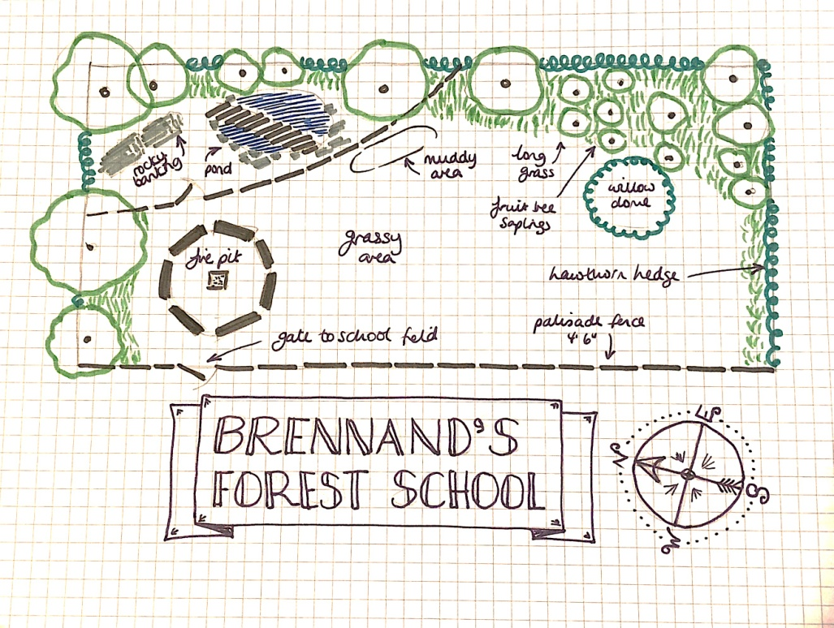

Transforming this into a wooded area will take some careful planning and many years of maintenance and care. Our environmental management plan will consider our needs now and in the future.

Year 2020/21:

* Review environmental impact assessment of the current site
* Discuss findings with Brennand’s (the land owner) as well as with other Forest School leaders to explore options
* Maintain current planting; carry out appropriate pruning; check fencing and gate Establish new permanent fire pit and tarp posts (work to start Jan 2021)
* Clear path and tidy around the pond area

Year 2021/22

* Review environmental impact assessment and monitor site
* Review impact of current planting and hard landscaping on activities we offer
* Maintain hard landscaping
* Maintain current planting and pruning regime

Year 2022 and beyond:

* Monitor site and review environmental impact assessment
* Carry out further planting / pruning as needed

Alongside using our space as described above we will also research the possibility of using other local woodland areas, particularly ones within walking distance of the school, so that as we start to deliver more sessions we can manage the impact on what is a relatively small space at school.

## E: Environmental Impact Assessment

|  |  |  |  |
| --- | --- | --- | --- |
| Brennand’s is mainly meadow with a few mature trees at the boundary and a cluster of young trees (< 10 years old).  A permanent seating circle and fire pit has just been installed along with den building poles. | | | |
| **Activity** | **Impact on ground layer** | **Impact on field,shrub or canopy** | **How to reduce impact** |
| General footfall | Trampling ground.  Disturbing habitats and invertebrates. | Damaging grasses and wildflowers.  Disturbing nests and dens. | Use designated pathways.  Agree free to roam areas which can be rotated.  Agree footstep free areas.  Educate about how we are visitors to this habitat. |
| Fire lighting and cooking | Scorched earth.  Change in nutrient composition of soil (ash/composting litter).  Litter.  Disturbing habitats.  Use fallen sticks and leaves as fuel, leaving limited options for other uses (site is not a woodland). | Disturbing habitats (invertebrates/birds)  Inappropriate use of living wood. | Ensure use of fire is meaningful.  Use permanent fire pit area.  Check for animal habitats.  Provide fuel from off site.  Scatter ashes.  Remove all litter and food waste. |
| Den building and other natural crafts | Trampled ground | Inappropriate use of resources/ destruction of living wood and plants. | Use designated den building areas. Have fallow week is foot fall heavy and weather bad.  Use den building sticks and other resources to be reused and recycled.  Get learners to consider the impact their den building/crafting is having on the site. |
| Minibeast hunting | Disturbing habitats  Trampling round. | Disturbing nests, breaking and trampling grasses and wild flowers. | Learners take responsibility by understanding impact on the flora and habitats.  Use free to roam areas.  Get children to empathise with the creatures.  Ensure all creatures replaced in original habitat. |

## F: Brennand’s Behaviour Policy

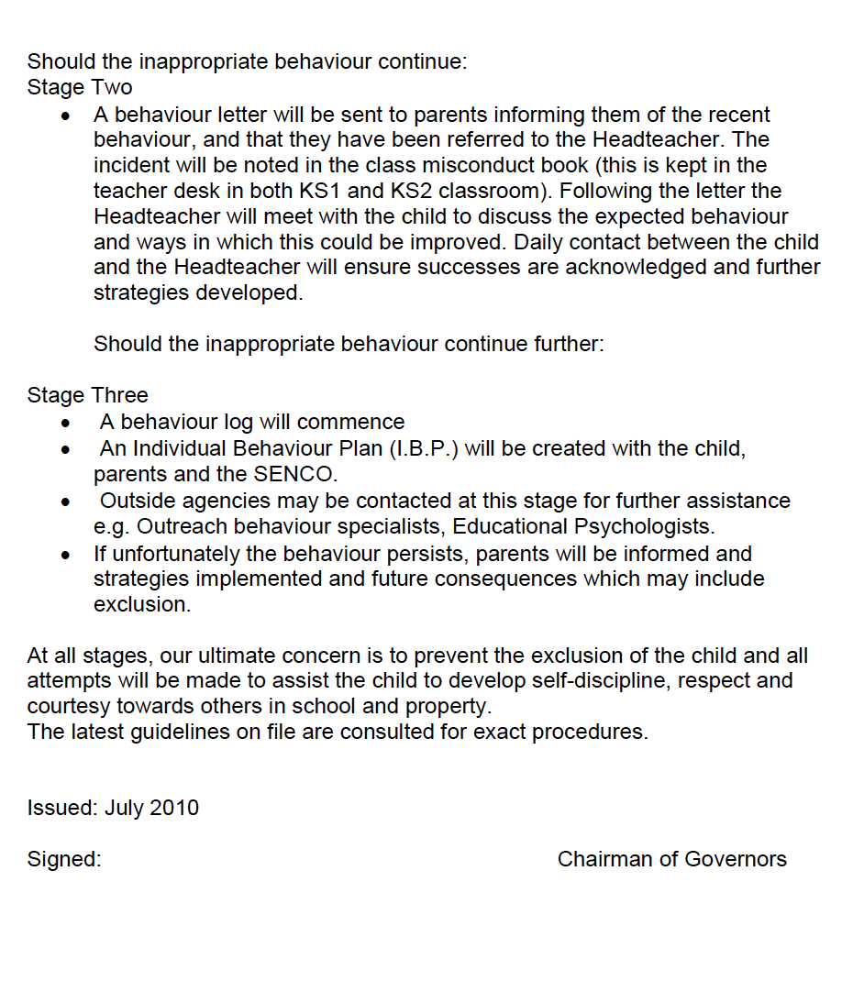

## G. Brennand’s Equality Policy

Brennand’s Endowed Primary School

**Policy Document**

EQUALITY POLICY STATEMENT

Since the Equality Act 2010 came into effect in April 2011, there has no longer been a requirement that schools should draw up and publish equality schemes or policies.

Schools now must:

* Publish information showing compliance with the General Duty, showing how we have due regard to equalities and meet the three aims of the Act:
* To eliminate discrimination, harassment or victimisation and any other conduct prohibited under the Act;
* Advance equality of opportunity between persons who share a protected characteristic;
* Foster good relations between persons who share a protected characteristic and those who do not;
* Prepare and publish equality objectives which they will pursue over the next three years to achieve the three aims of the Act.

**AIMS AND VALUES**

* Every person in the school community, and beyond, is of equal value and should be treated fairly and with respect.
* The culture and background of all members of the school community, and beyond, are treated positively and with respect.
* We foster positive attitudes and relationships, and a shared sense of cohesion and belonging.

**ELIMINATING DISCRIMINATION, ADVANCING EQUALITY OF OPPORTUNITY AND FOSTERING GOOD RELATIONSHIPS**

* We intend that all school policies, procedures and activities should promote positive attitudes, interaction, good relations and communication between groups and communities different from each other.
* Our whole school behaviour policy is reviewed regularly with staff, pupils and governors and makes explicit reference to zero tolerance of any bullying, including that of a homophobic nature.
* We ensure that policies and procedures should benefit all employees and potential employees, for example in recruitment and promotion, and in continuing professional development.
* Within school we hold data broken down according to year group, gender, ethnicity and types of disability or special educational need. Data related to attainment is analysed half termly.
* The school is opposed to all forms of prejudice which stand in the way of fulfilling our legal duties under the Equality Act 2010, the Education and Inspections Act 2006 and the UN Convention on the Rights of the Child, the UN Convention on the Rights of People with Disabilities, and the Human Rights Act 1998.

**ROLES AND RESPONSIBILITIES**

* The governing body is responsible for ensuring that the school complies with legislation, and that this policy and its related procedures and action plans are implemented.
* The headteacher is responsible for implementing the policy; for ensuring that all staff are aware of their responsibilities and are given appropriate training and support; and for taking appropriate action in any cases of unlawful discrimination.
* All staff are expected to:

- promote an inclusive and collaborative ethos in their classroom

- deal with any prejudice-related incidents that may occur

- plan and deliver a curriculum and lessons that reflect our principles that all learners are of equal value,

**TRAINING AND PROMOTION**

* Opportunities for involvement in training and development activities will be positively encouraged.
* Through our policy, we will seek to broaden the understanding of staff, governors and pupils of the continuing need to challenge inequality within our society.

**BREACH OF POLICY**

It is our corporate responsibility to ensure full support for and endorsement of our Equalities policy. Any breaches will be reported to the Headteacher.

**MONITORING and REVIEW**

We collect, analyse and use data in relation to achievement, broken down as appropriate according to gender, special educational needs, language, ethnicity and disability.

**EQUALITY OBJECTIVES**

We aim to provide the highest possible education for all at Brennand’s Endowed CE (VA) Primary School. The ethos of our school clearly reflects our commitment to fully including, respecting and supporting all members of our school community whatever their cultural background, belief, gender, race or disability.

Following feedback from parents, consultation with our Governing Body and review of our equality information, the following objectives have been set for 2015-2019:-

**Objective 1:** To ensure that the curriculum effectively supports the needs of all children to ensure good or outstanding progress is made by all pupils in reading, writing and mathematics.

**Objective 2:** To further develop a curriculum with a global dimension to develop pupils’ positive attitudes to communities different from their own.

## H: Brennand’s Medication Policy

Brennand’s Endowed Primary School

**Policy Document**

**ADMINISTRATION OF MEDICATION IN SCHOOL**

The governing body recognises that many pupils will at some time need to take medication at school. While parents retain responsibility for their child's medication, the school has a duty of care to the pupils while at school, and the governing body wishes to do all that is reasonably practicable to safeguard and promote children's welfare.

**Responsibilities:**

* The governing body takes responsibility for the administration of medicines during school time in accordance with the government's and LEA's policies and guidelines.
* The Head will implement this policy and report as required to the governing body.
* Medication will normally be administered by specially designated staff.
* All staff are expected to maintain professional standards of care, but have no contractual or legal duty to administer medication. The governing body and the Head do not require staff to administer medication.

However, some specified staff (e.g. PE and games staff, or staff taking educational visits) who volunteer their services, will be given training to administer first aid and/or medication to pupils.

**Staff Indemnity**

The LEA (governing body) fully indemnifies all staff against claims for any alleged

negligence, providing they are acting within their conditions of service and following

governing body guidelines.

**Procedures**

* Medication will not be accepted in school without complete written and signed instructions from the parent.
* Only reasonable quantities of medication should be supplied to the school (for example, a maximum of four weeks supply at any one time).
* Each item of medication must be delivered in its original container and handed directly to the Headteacher (or to a nominated person authorised by the Headteacher).
* Where the pupil travels on school transport with an escort, parents/carers should ensure the escort is informed of any medication sent with the pupil, including medication for the administration during respite care.
* Each item of medication must be clearly labelled with the following information:
* Pupil’s name
* Name of Medication
* Dosage
* Frequency of dosage
* Date of dispensing
* Storage requirements (if important)
* Expiry date
* The school will not accept items of medication which are in unlabelled containers.
* Unless otherwise indicated all medication to be administered in school will be kept in a locked medicine cabinet.
* The school will provide parent/ carers with details of when medication has been administered to their child.
* Where it is appropriate to do so pupils will be encouraged to administer their own medication, if necessary under staff supervision. Parents/carers will be asked to confirm in writing if they wish their child to carry their medication with them in school.
* It is the responsibility of parents/carers to notify the school if there is a change in medication, a change in dosage requirements, or the discontinuation of the pupil’s needs for medication.
* Staff who volunteer to assist in the administration of medication will receive appropriate training/guidance through arrangements made with the School Health Service.
* The school will make every effort to continue the administration of medication to a pupil whilst at school or on trips away from the school premises, even if additional arrangements might be required. However, there may be occasions when it may not be possible to attend school or to include a pupil on a school trip if appropriate supervision cannot be guaranteed.

# Please sign to confirm you have read this Handbook…

|  |  |  |  |
| --- | --- | --- | --- |
| Name | Role | Read? Sign below | Date |
|  |  |  |  |
|  |  |  |  |
|  |  |  |  |
|  |  |  |  |
|  |  |  |  |
|  |  |  |  |
|  |  |  |  |
|  |  |  |  |
|  |  |  |  |
|  |  |  |  |
|  |  |  |  |
|  |  |  |  |

# Review schedule

|  |  |  |  |
| --- | --- | --- | --- |
| Version | Written / reviewed by | Summary of changes | Date |
| 1 | Sarah Makinson & Sarah Snape | New handbook | June 2018 |
| 2 | Helen Murray | Handbook updated | October 2020 |
|  |  |  |  |
|  |  |  |  |
|  |  |  |  |

# Attached Files

## 🞏 Forest School Qualification(s)

## 🞏 First Aid Certificate(s)

## 🞏 DBS Certificate(s)

## 🞏 Food Hygiene Certificate(s)

## 🞏 Insurance